# Synthesis Pathways

## Product 1

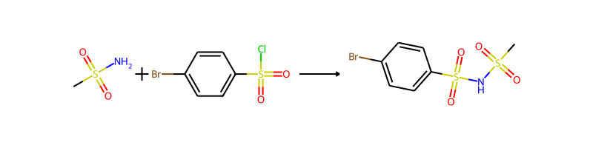

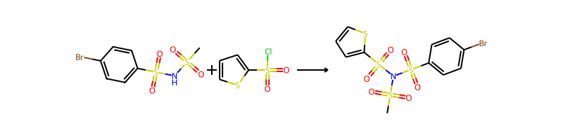

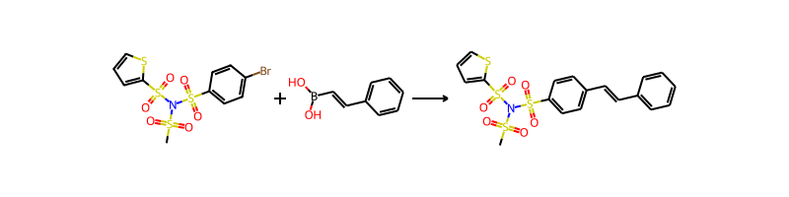

## Product 2

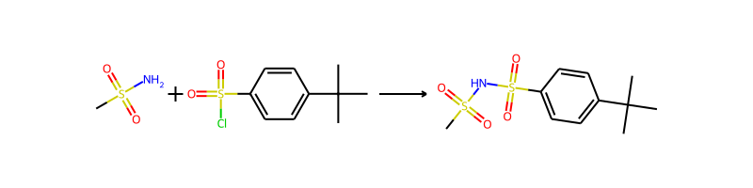

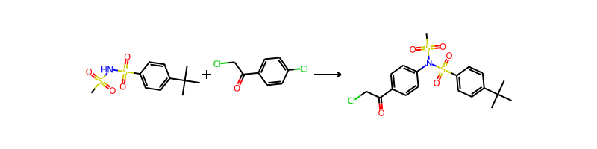

## Product 3



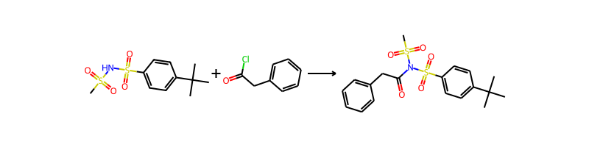

## Product 4



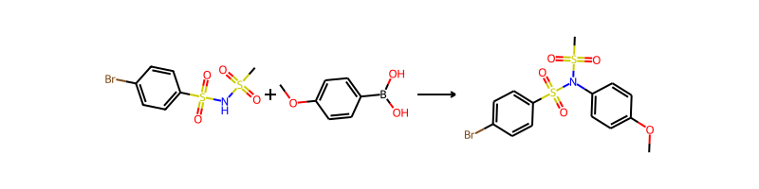

## Product 5

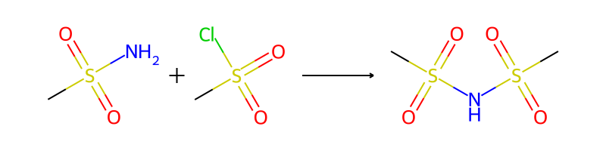

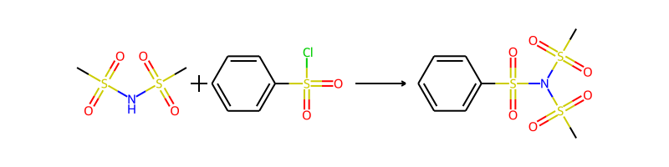

## Product 6





## Product 7



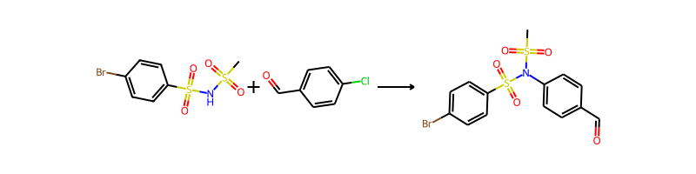

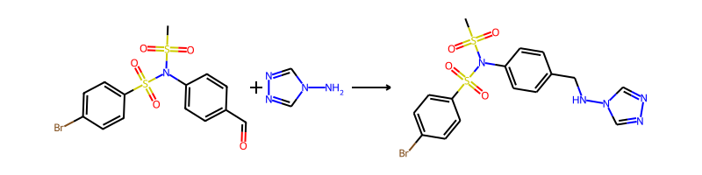

## Product 8

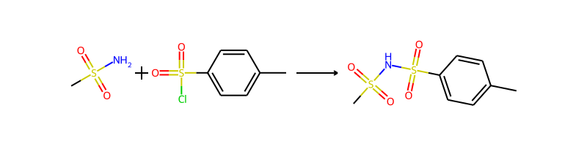

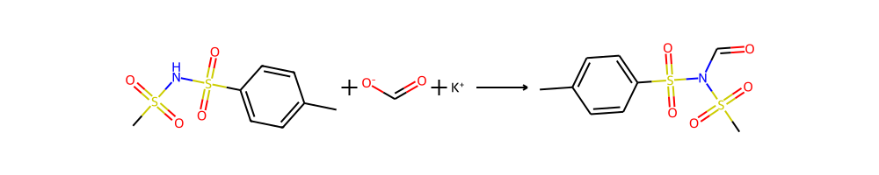

## Product 9



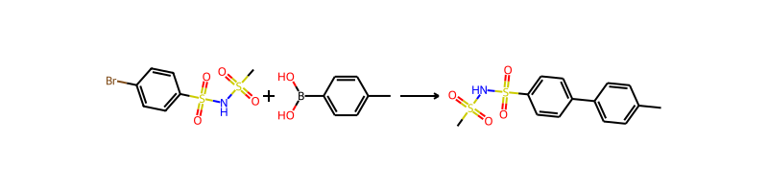

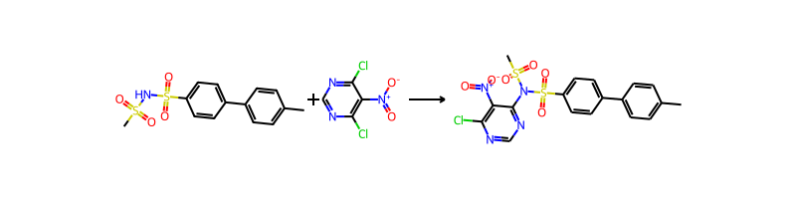

## Product 10







## Product 11

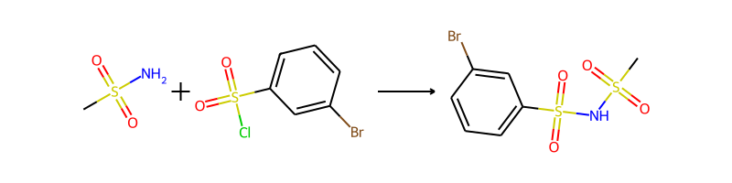

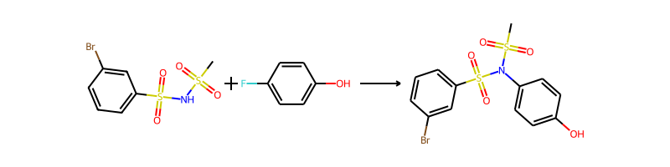

## Product 12



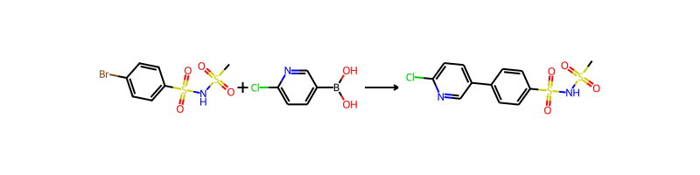

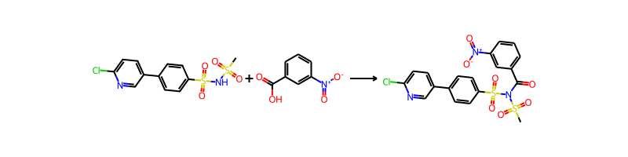

## Product 13

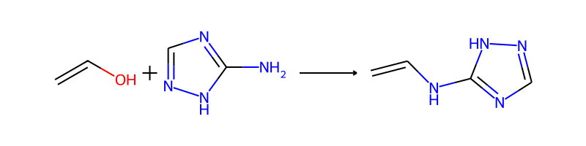

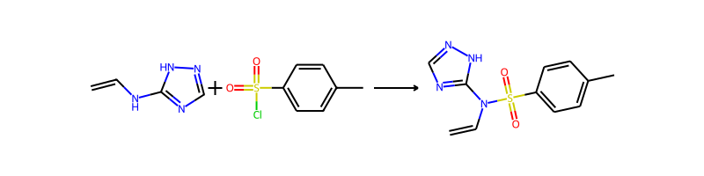

## Product 14

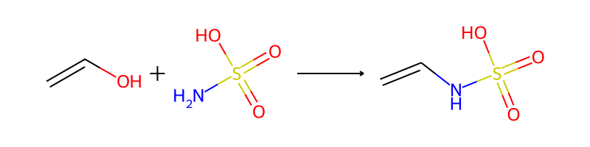

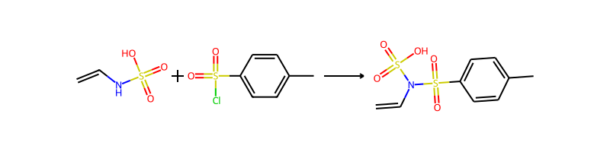

## Product 15

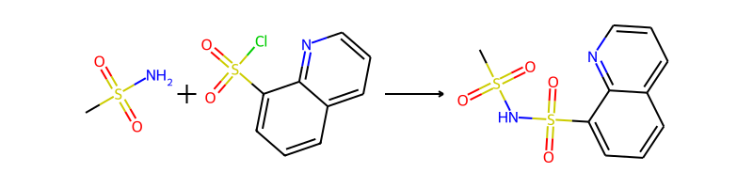

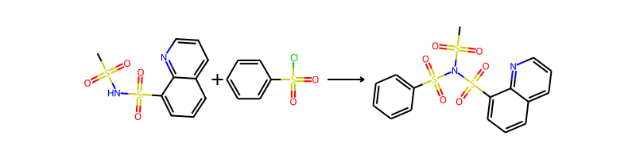

## Product 16

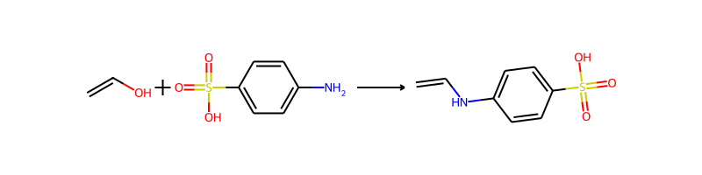

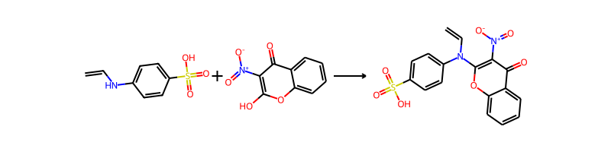

## Product 17

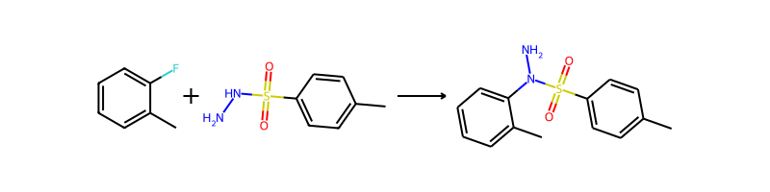

## Product 18

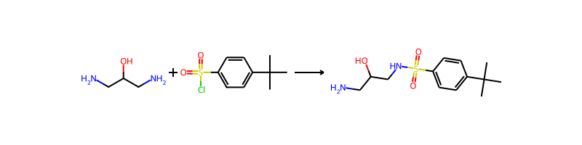

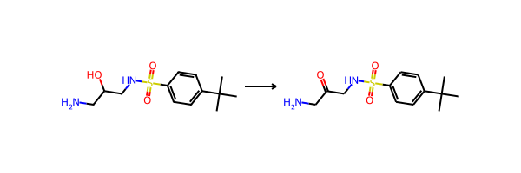

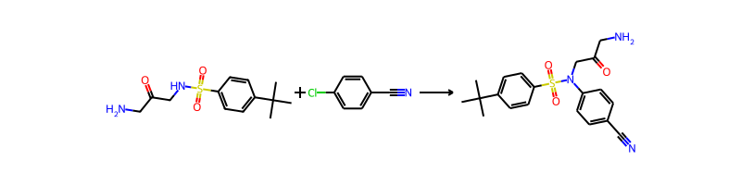

## Product 19

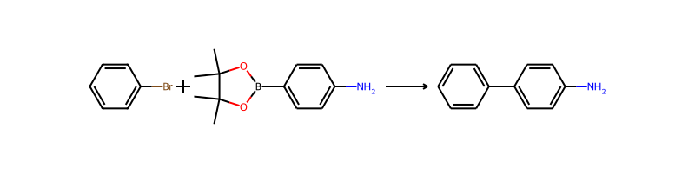

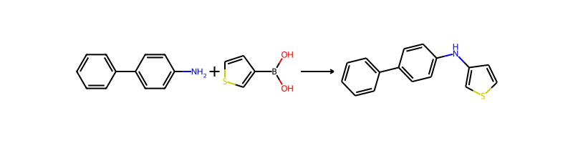

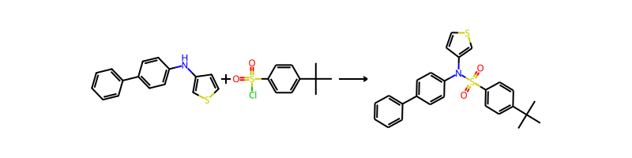

## Product 20



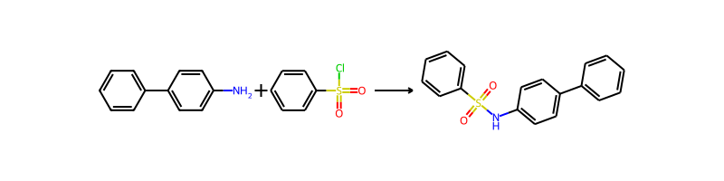

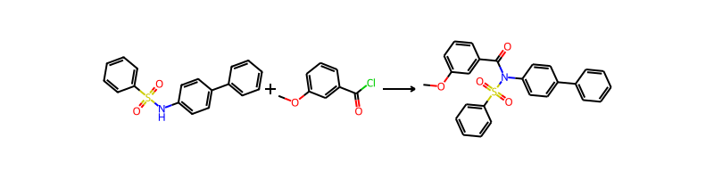

## Product 21

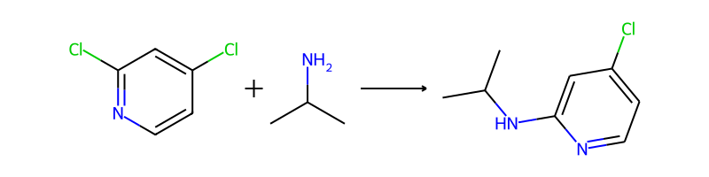

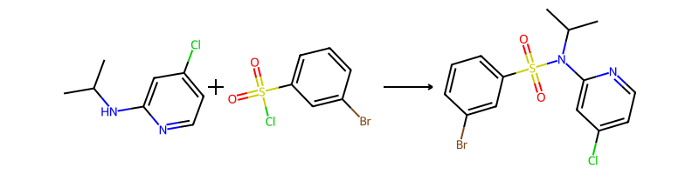

## Product 22





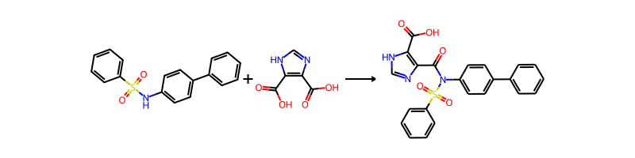

## Product 23





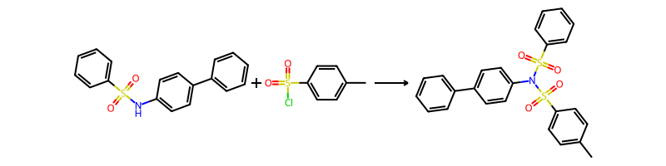

## Product 24



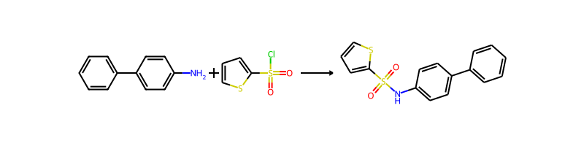

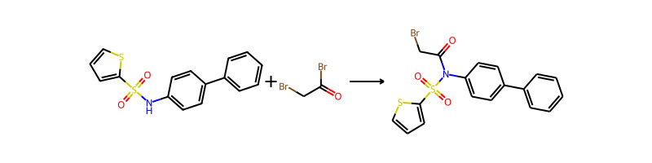

## Product 25





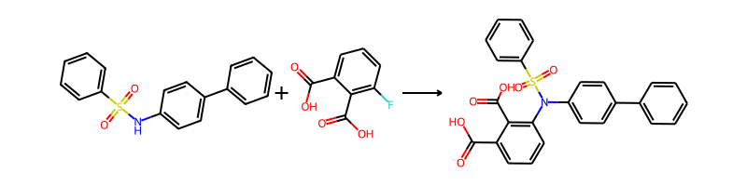

## Product 26

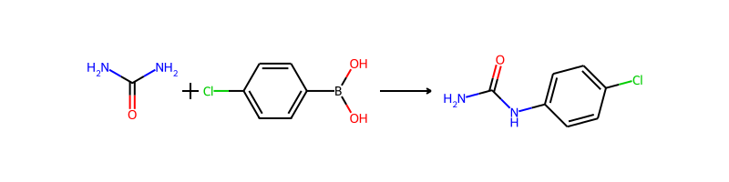

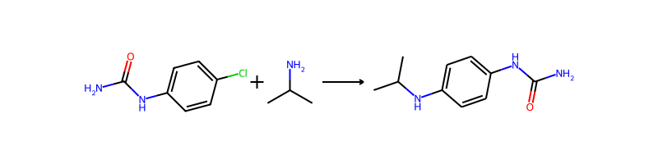

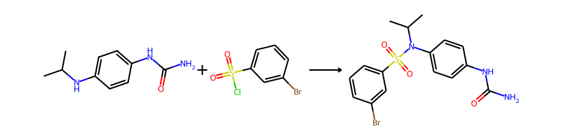

## Product 27



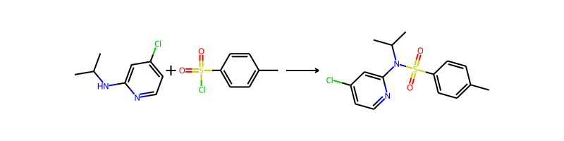

## Product 28





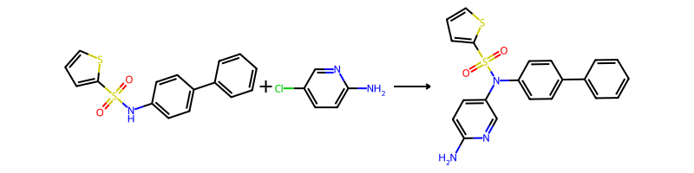

## Product 29



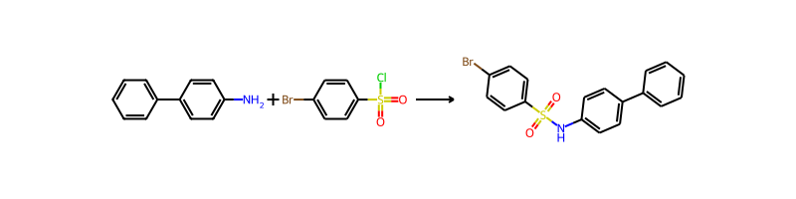

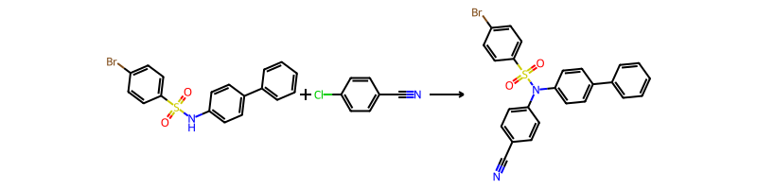

## Product 30



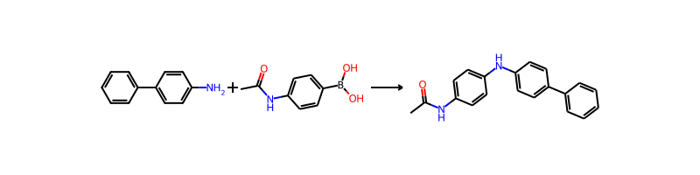

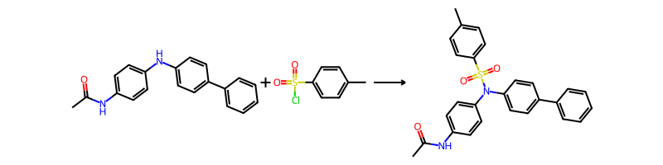

## Product 31

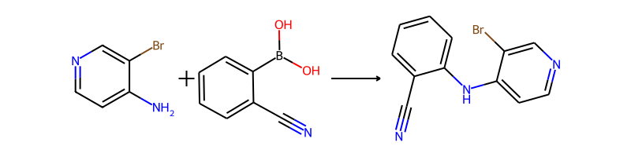

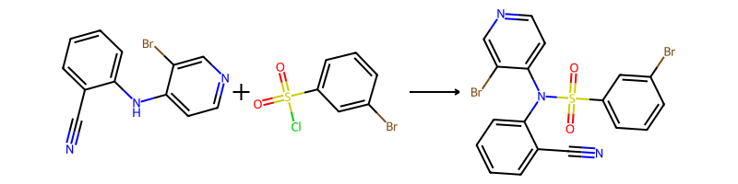

## Product 32

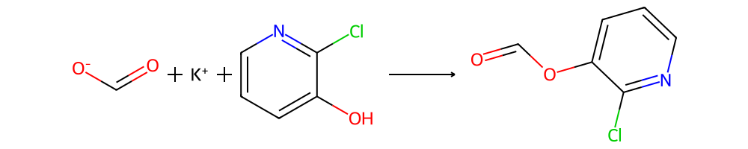

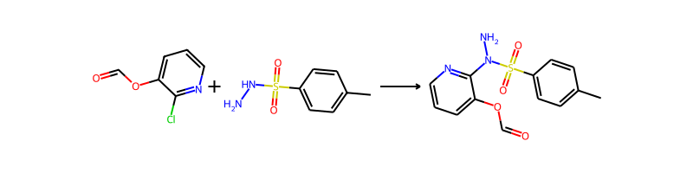

## Product 33

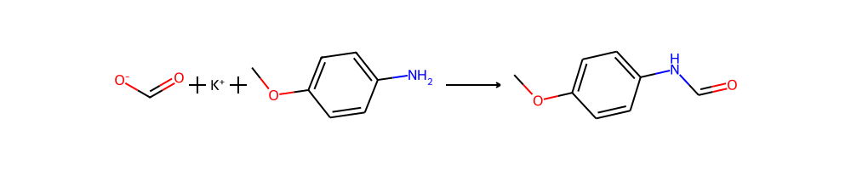

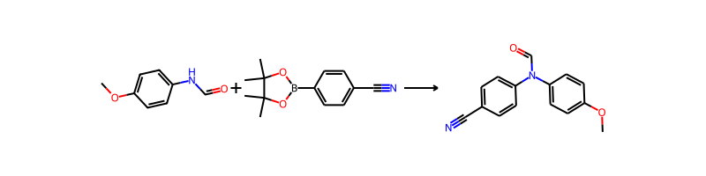

## Product 34

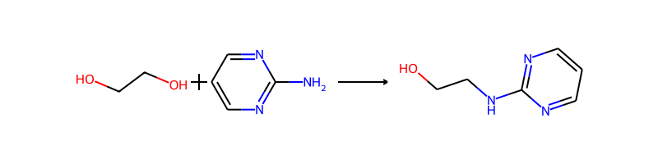

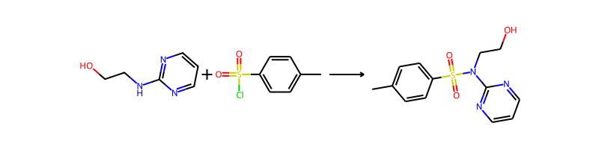

## Product 35

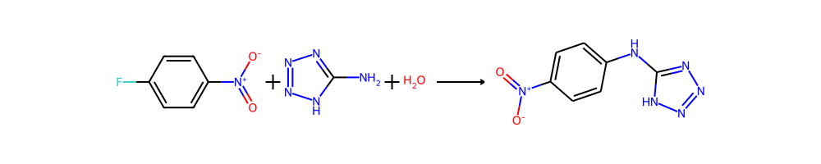

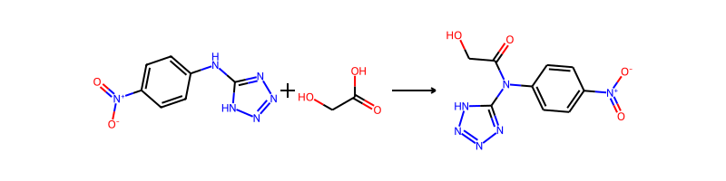

## Product 36

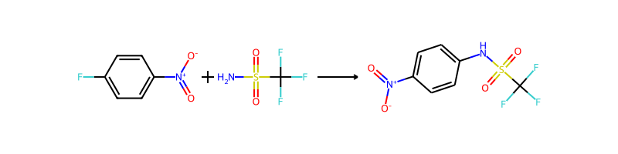

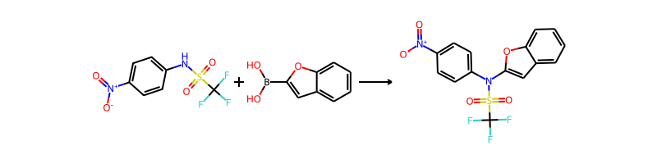

## Product 37



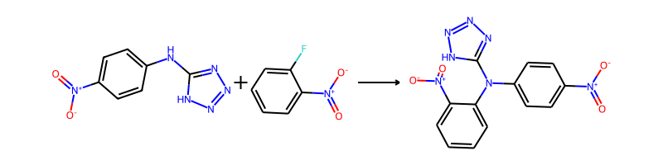

## Product 38

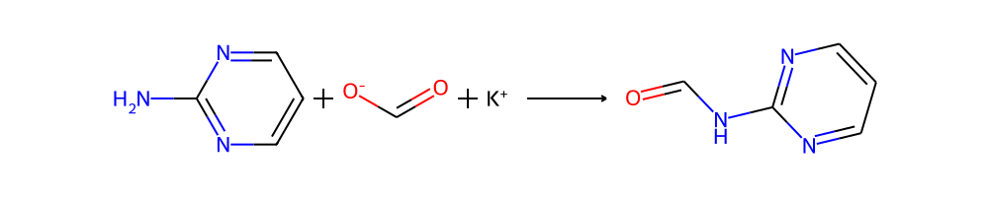

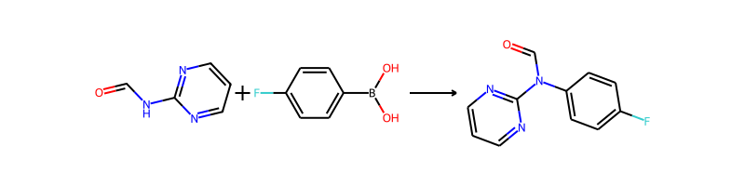

## Product 39

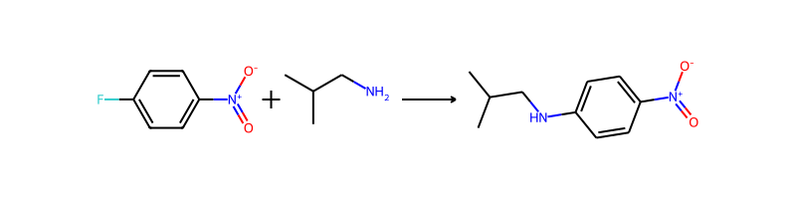

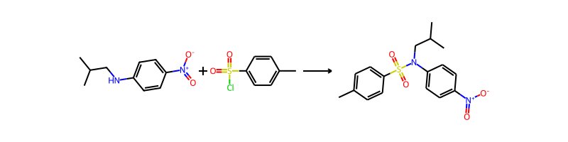

## Product 40

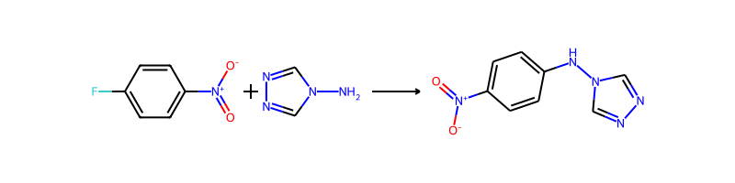

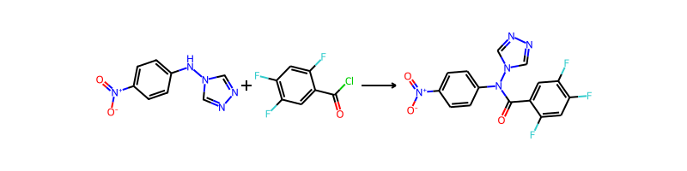

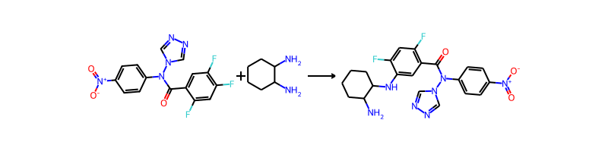

## Product 41

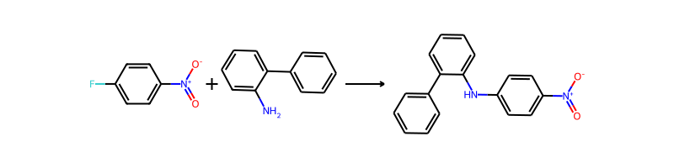

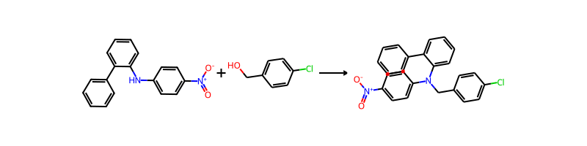

## Product 42

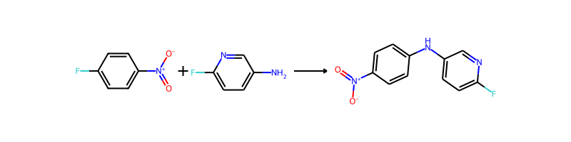

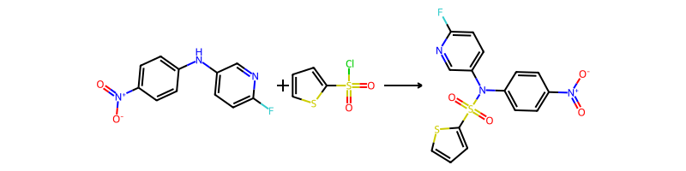

## Product 43





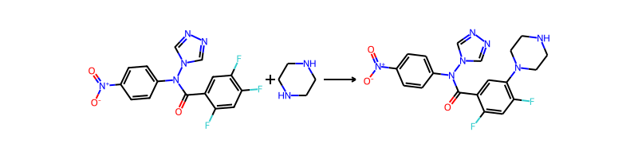

## Product 44



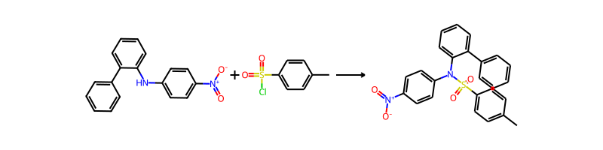

## Product 45

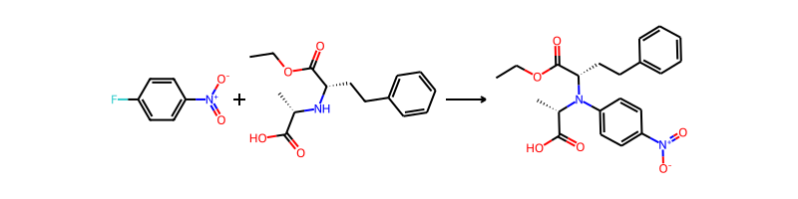

## Product 46

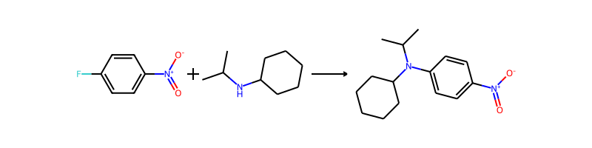

## Product 47

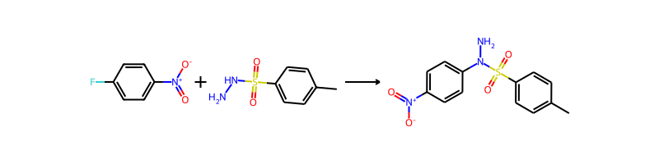

## Product 48



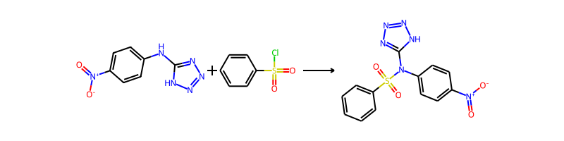

## Product 49

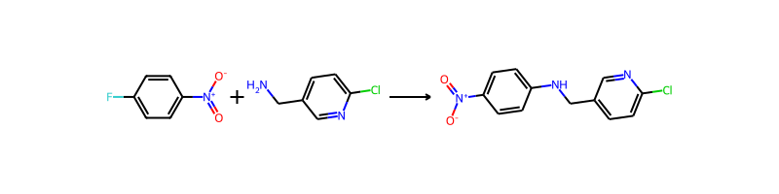

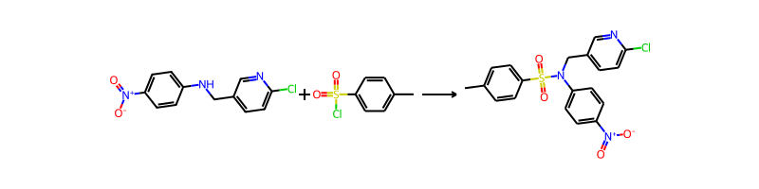

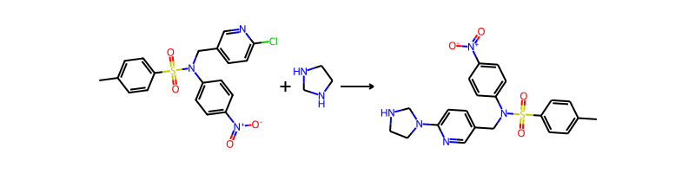

## Product 50

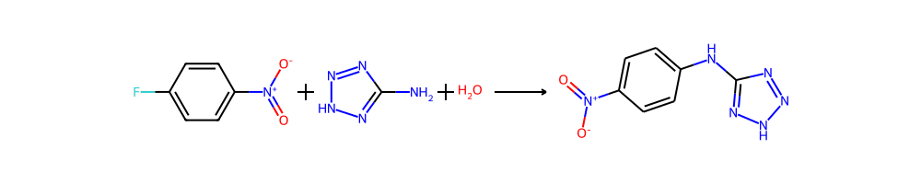

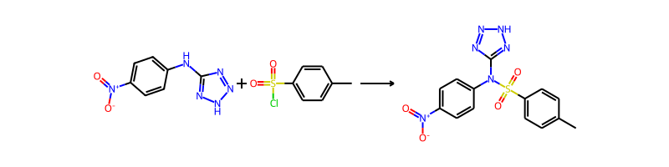

## Product 51

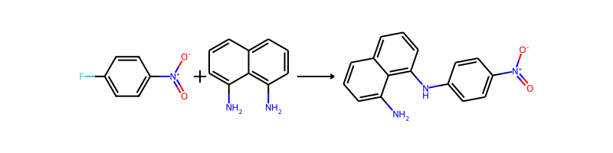

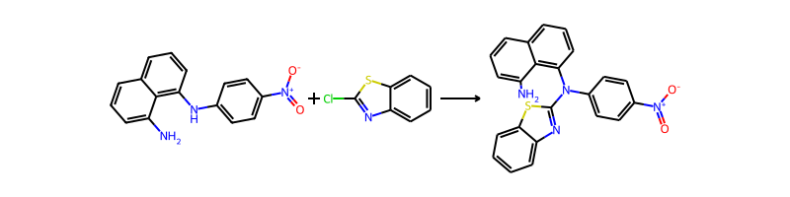

## Product 52



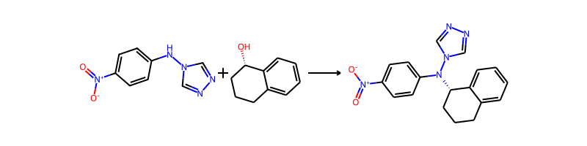

## Product 53

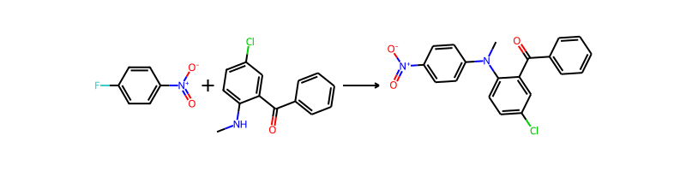

## Product 54

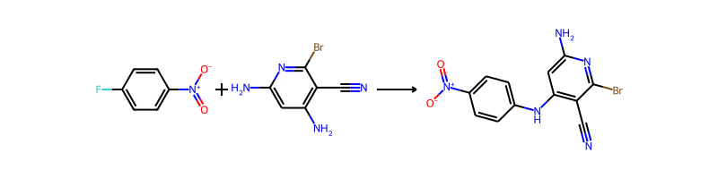

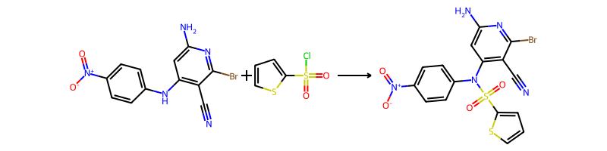

## Product 55

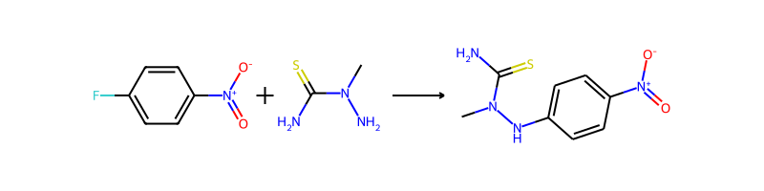

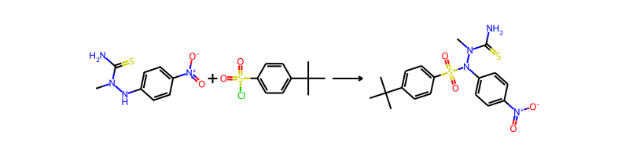

## Product 56

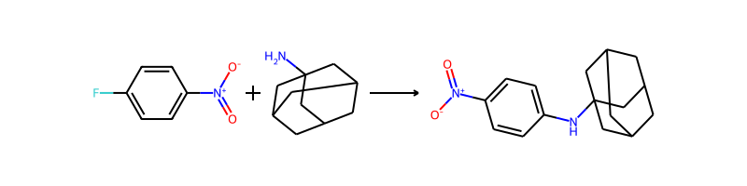

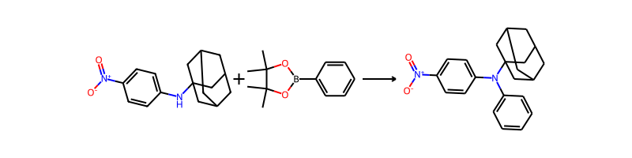

## Product 57



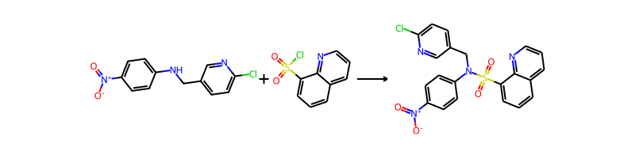

## Product 58



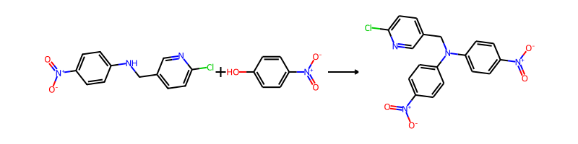

## Product 59

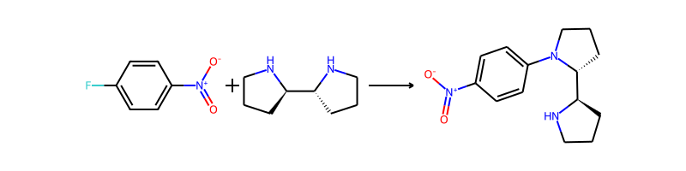

## Product 60



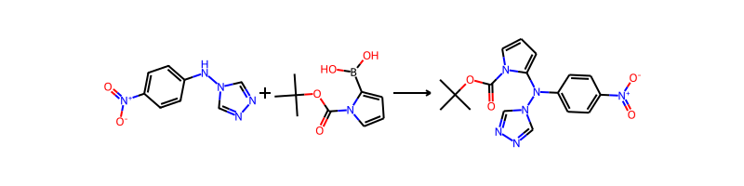

## Product 61



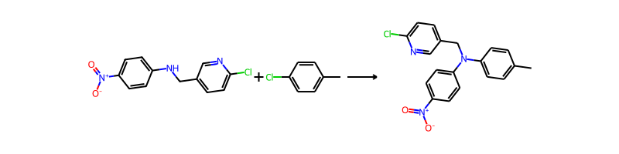

## Product 62



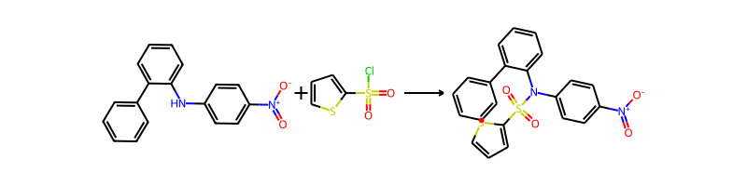

## Product 63





## Product 64



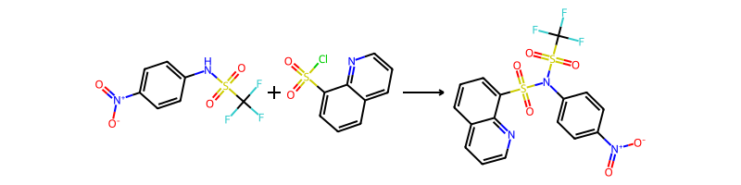

## Product 65



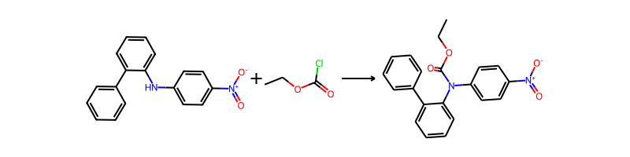

## Product 66

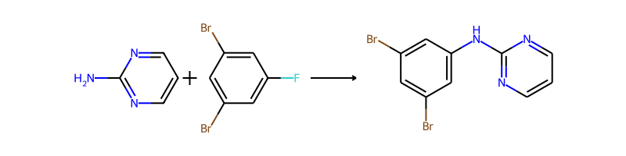

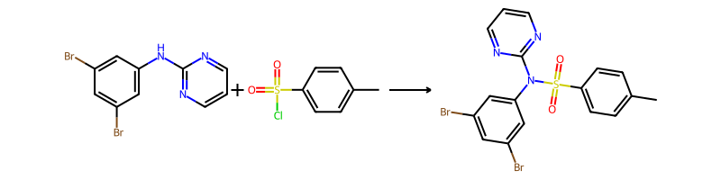

## Product 67

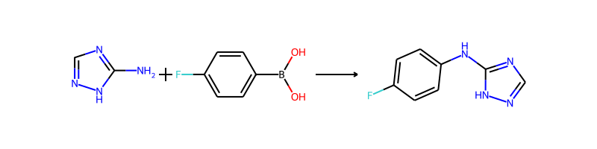

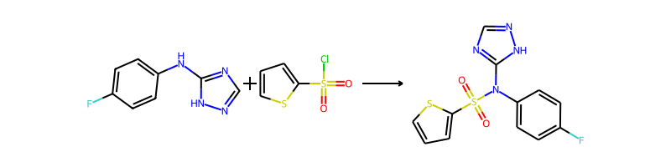

## Product 68



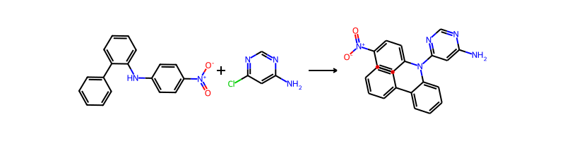

## Product 69

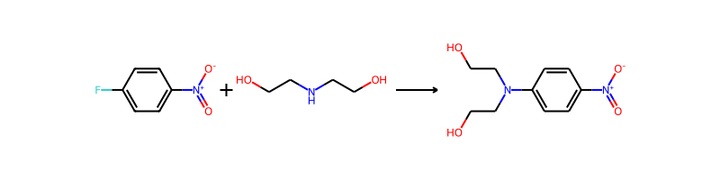

## Product 70

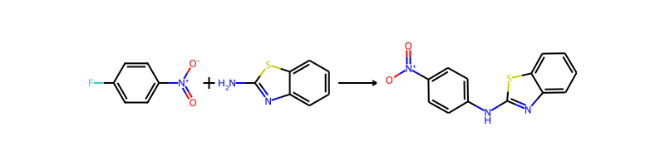

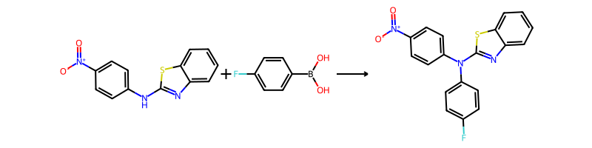

## Product 71



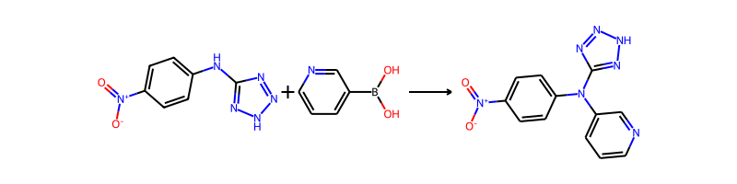

## Product 72



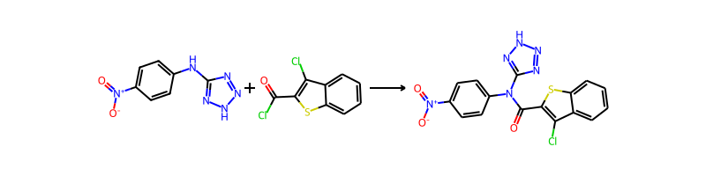

## Product 73

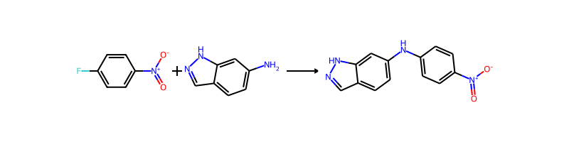

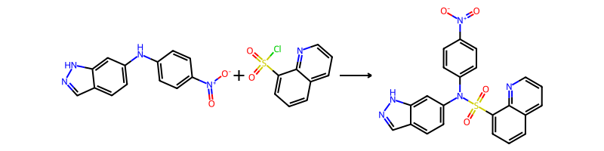

## Product 74

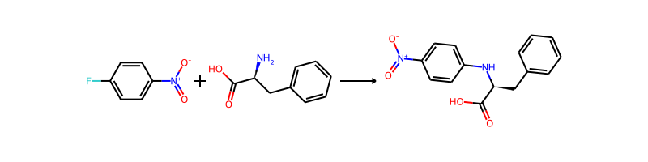

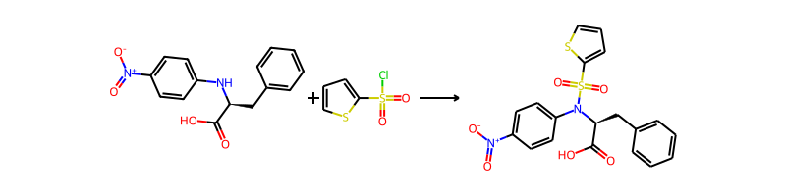

## Product 75



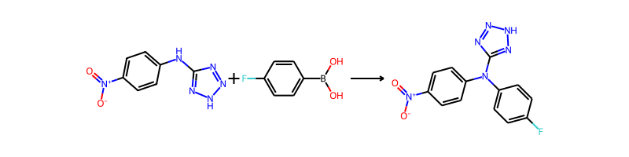

## Product 76

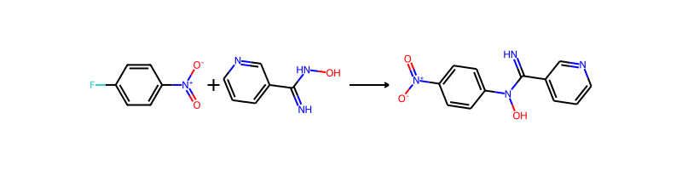

## Product 77



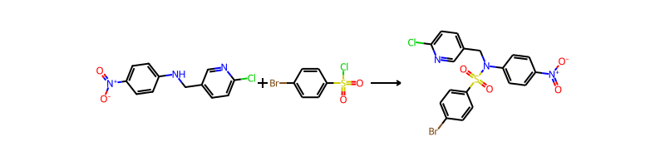

## Product 78

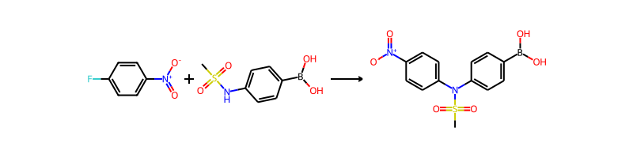

## Product 79



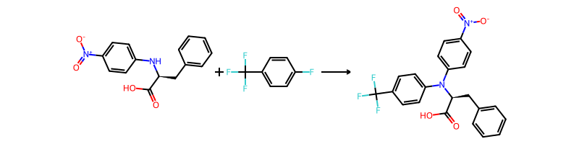

## Product 80



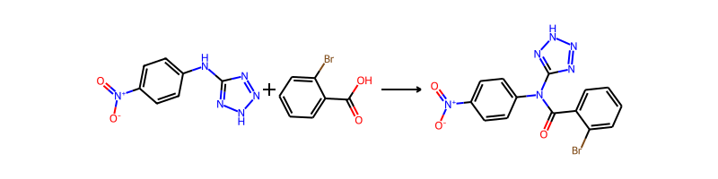

## Product 81

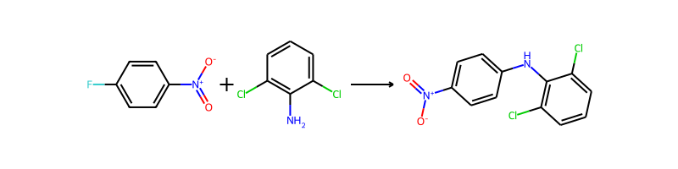

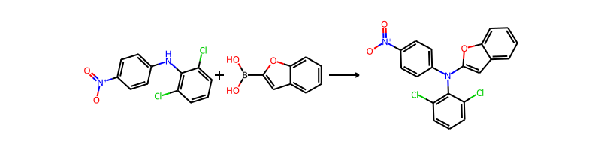

## Product 82

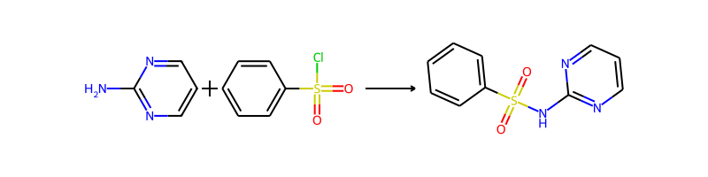

## Product 83

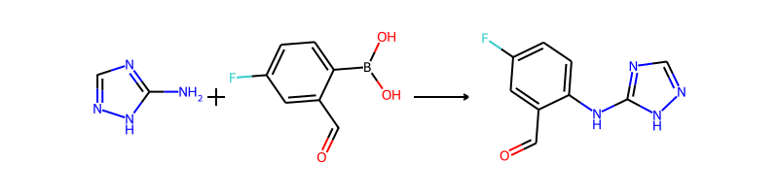

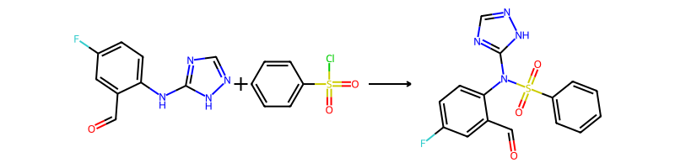

## Product 84



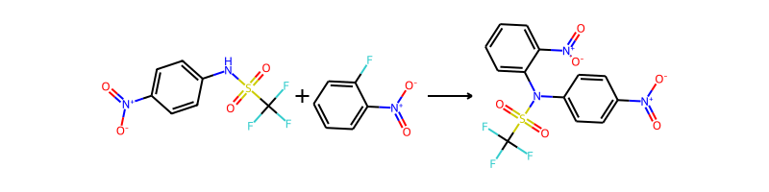

## Product 85

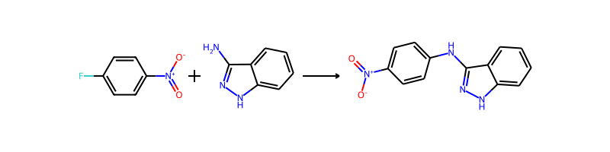

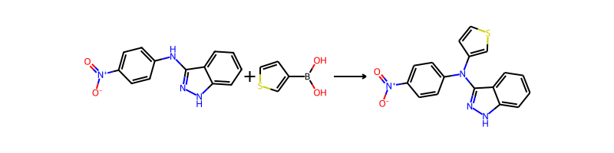

## Product 86



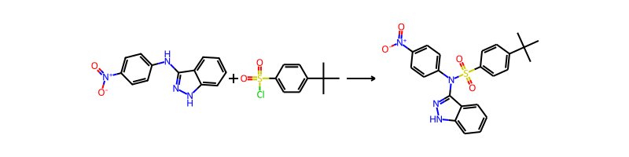

## Product 87

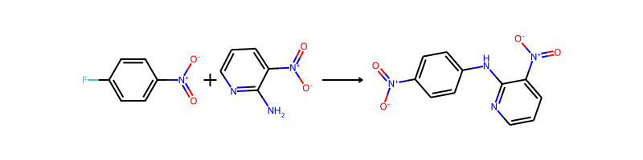

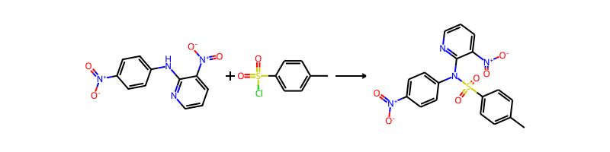

## Product 88

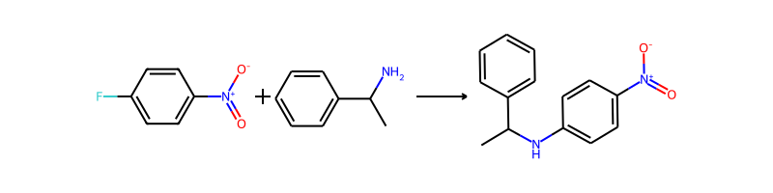

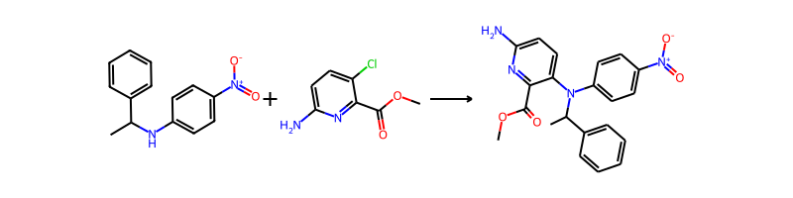

## Product 89

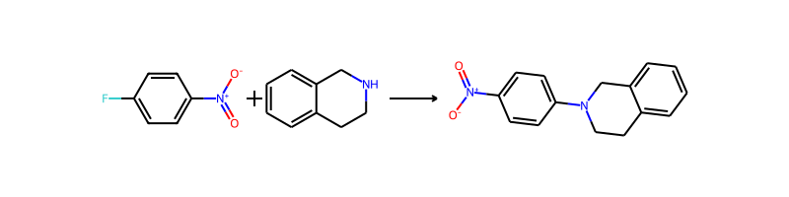

## Product 90



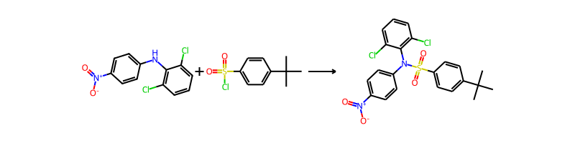

## Product 91



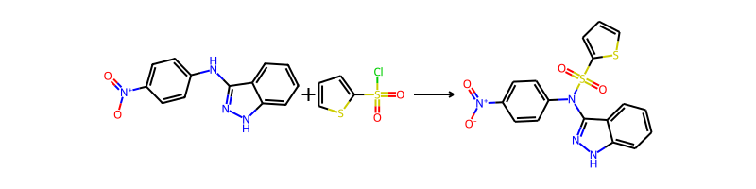

## Product 92

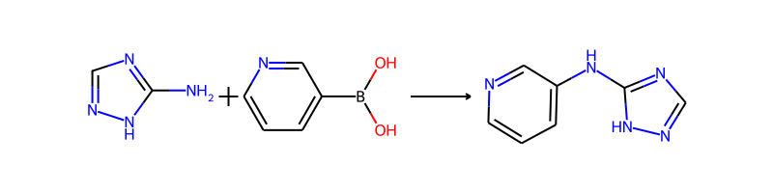

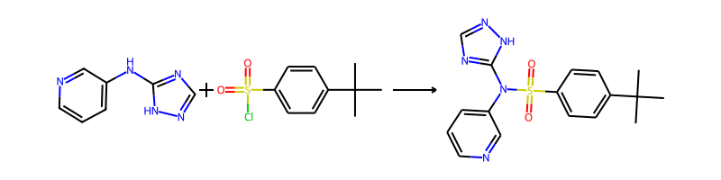

## Product 93



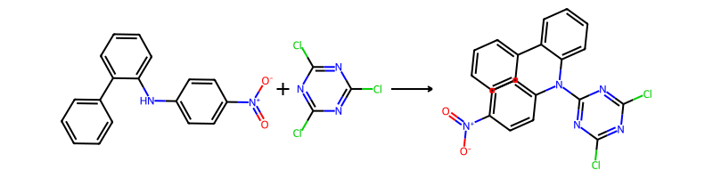

## Product 94

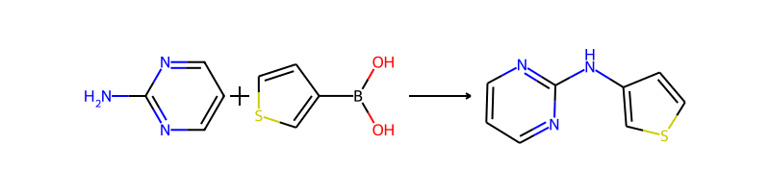

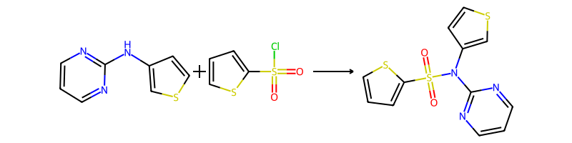

## Product 95



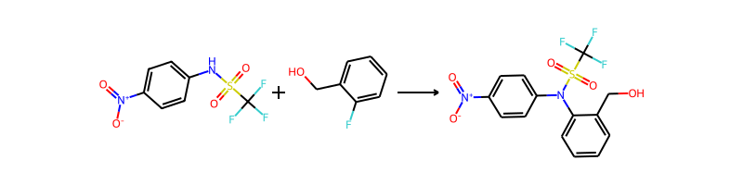

## Product 96



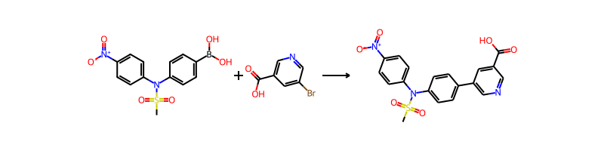

## Product 97

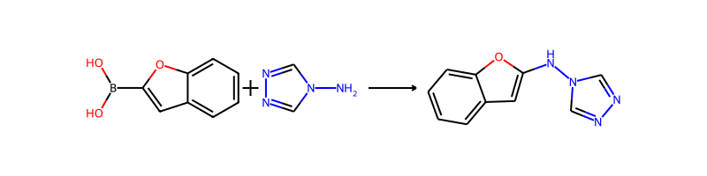

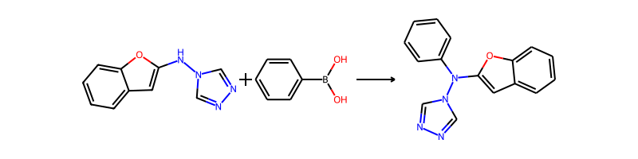

## Product 98

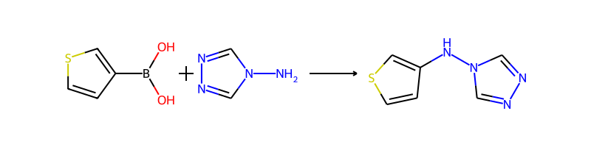

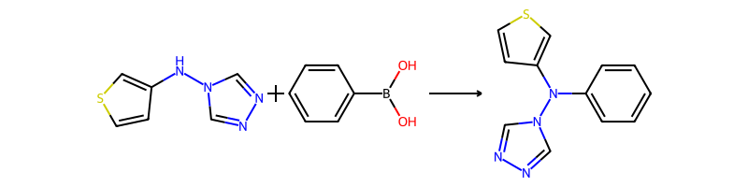

## Product 99

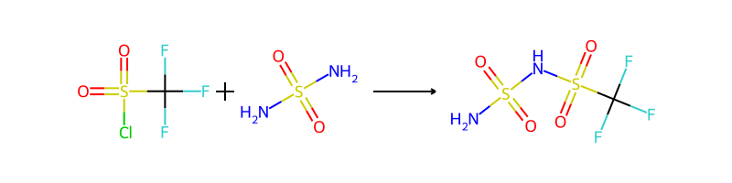

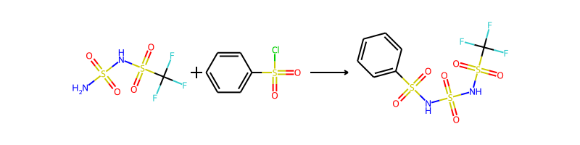

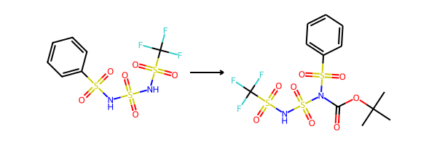

## Product 100

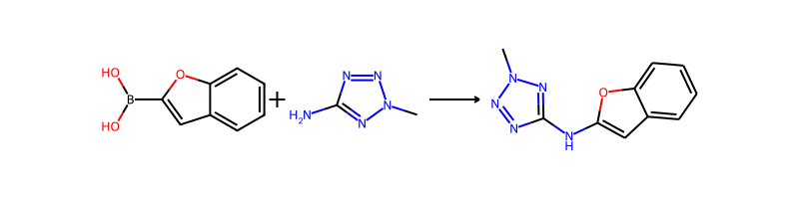

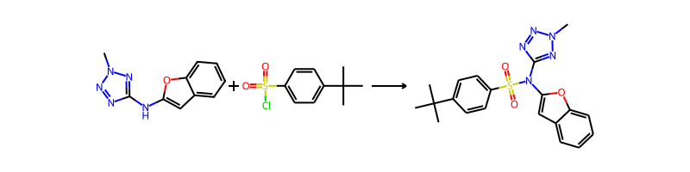

## Product 101



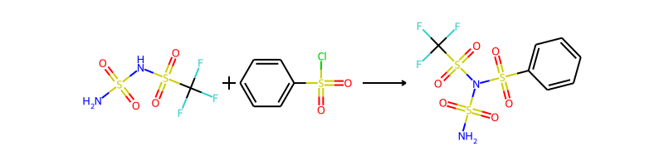

## Product 102

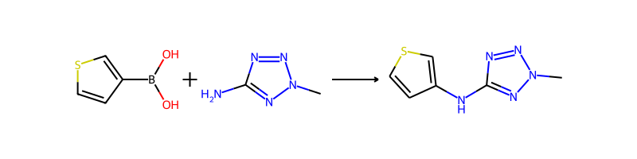

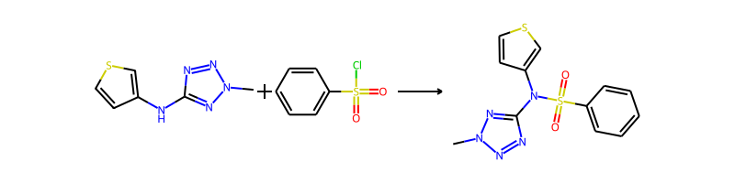

## Product 103

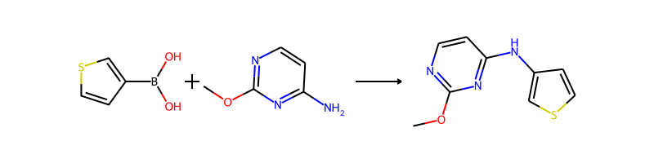

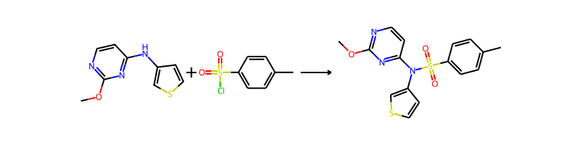

## Product 104

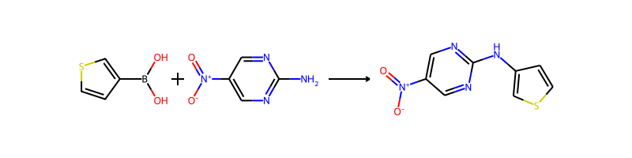

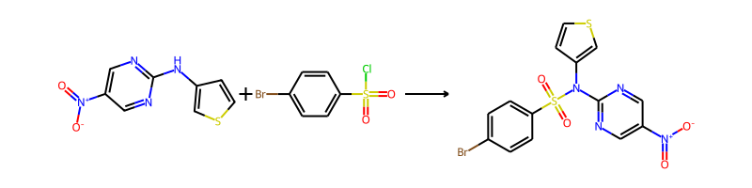

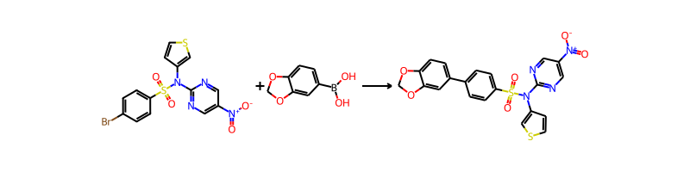

## Product 105

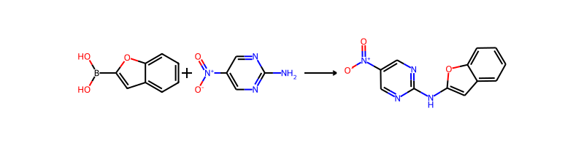

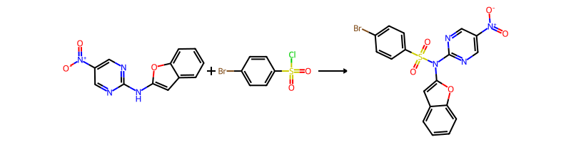

## Product 106

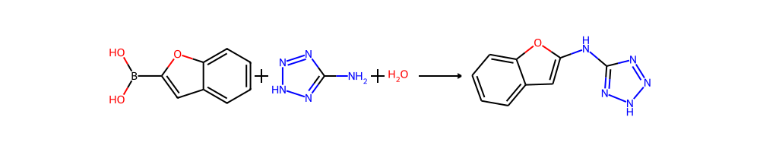

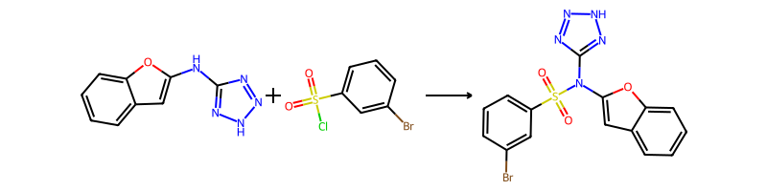

## Product 107



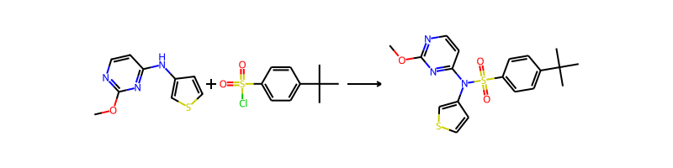

## Product 108

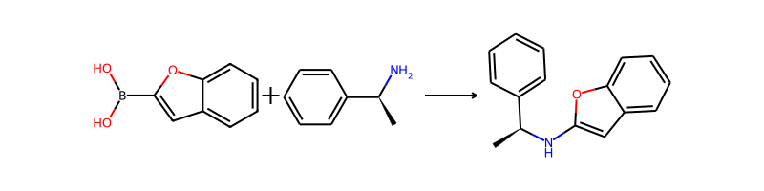

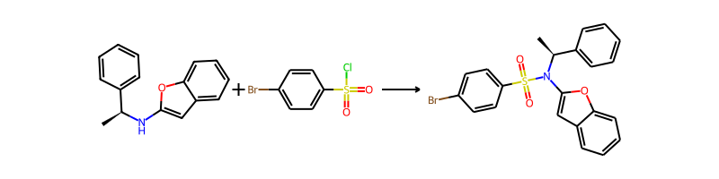

## Product 109

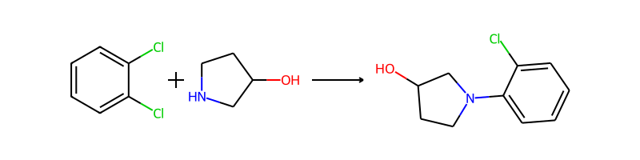

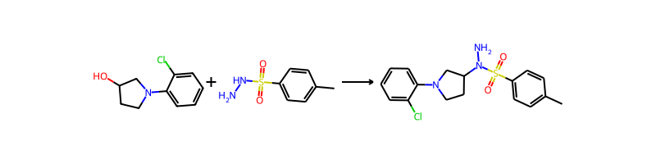

## Product 110

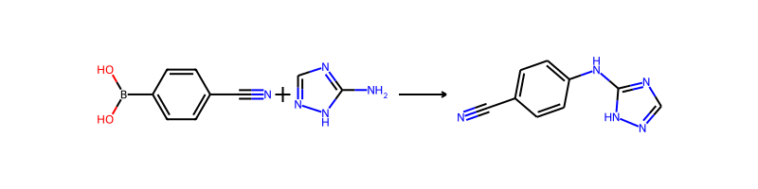

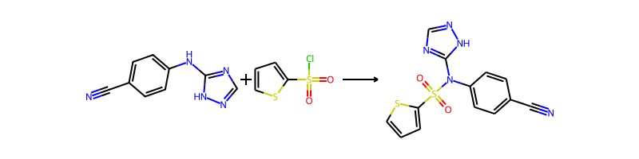

## Product 111

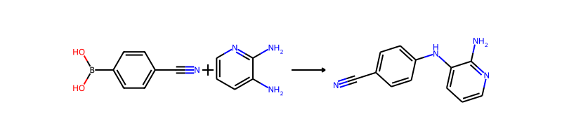

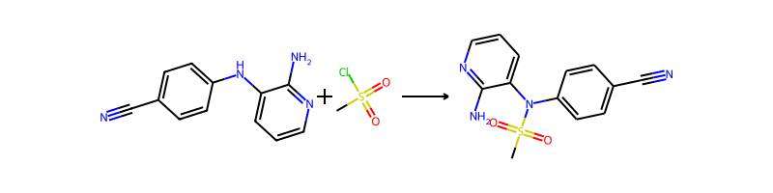

## Product 112

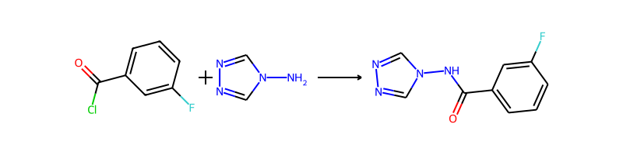

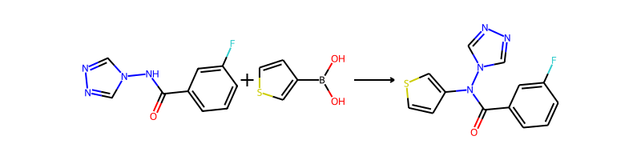

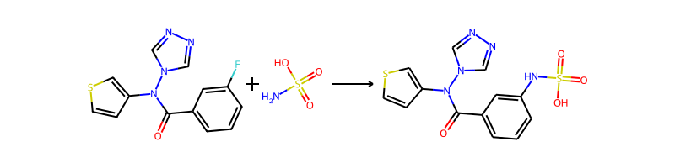

## Product 113

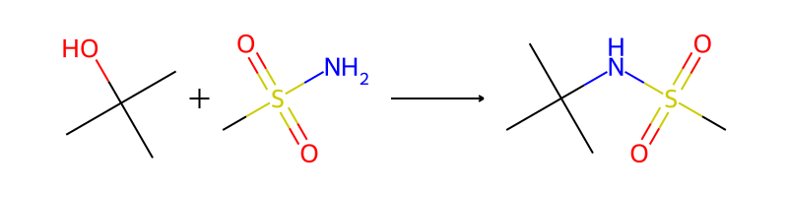

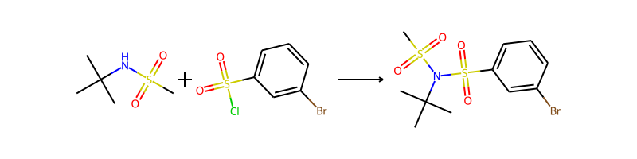

## Product 114

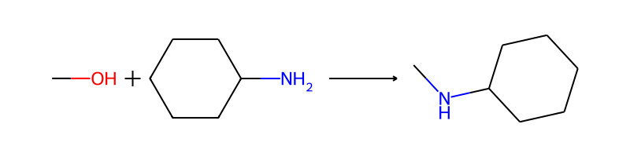

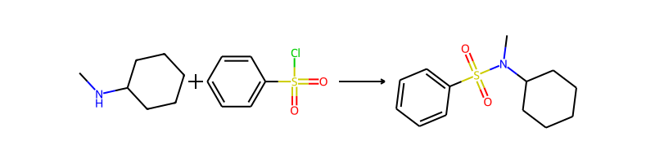

## Product 115

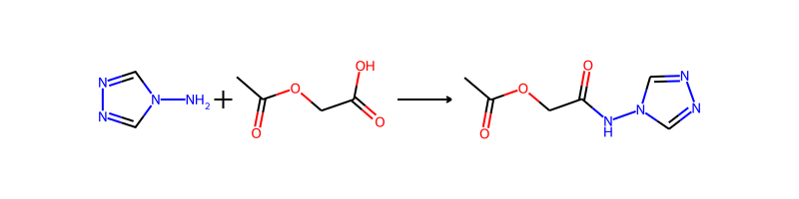

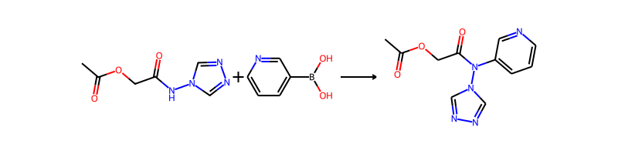

## Product 116

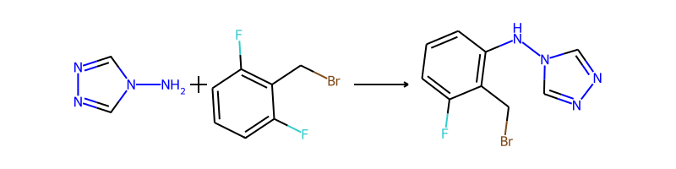

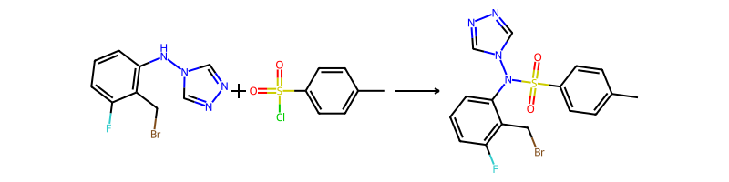

## Product 117

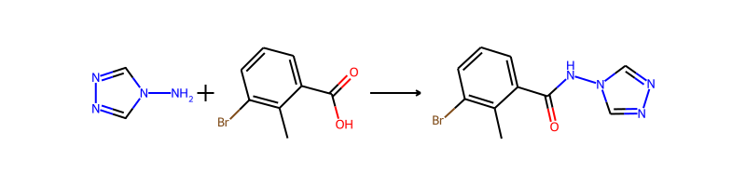

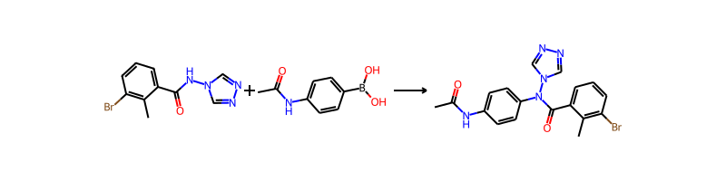

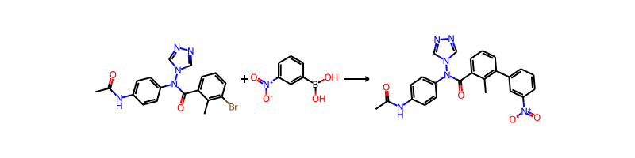

## Product 118

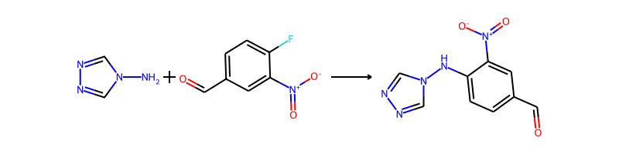

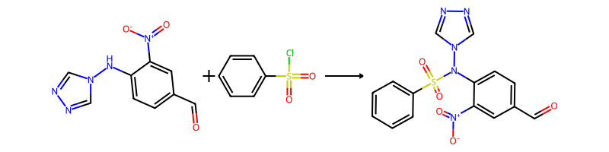

## Product 119



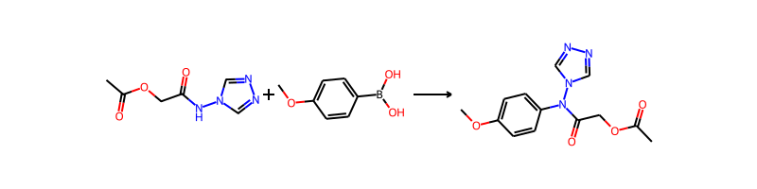

## Product 120





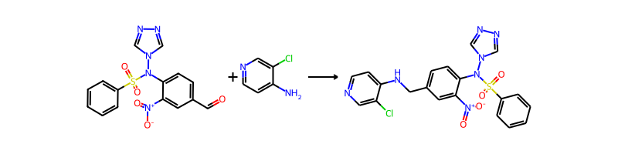

## Product 121





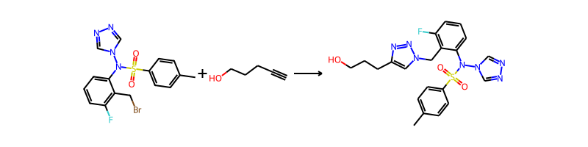

## Product 122

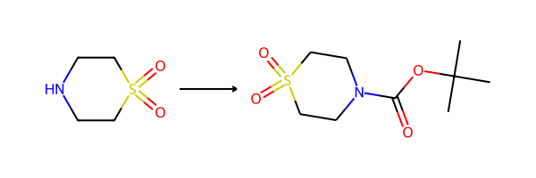

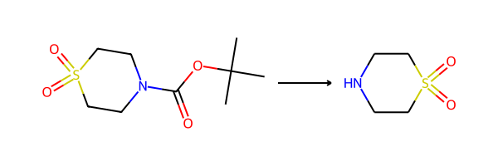

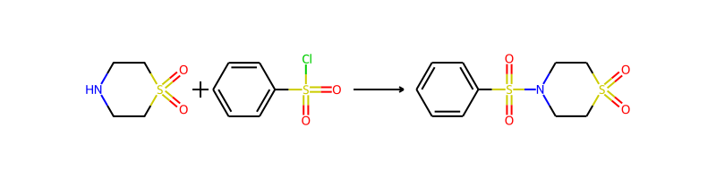

## Product 123



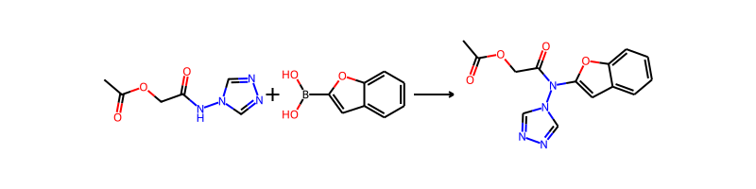

## Product 124

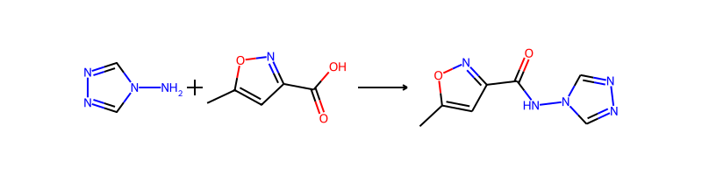

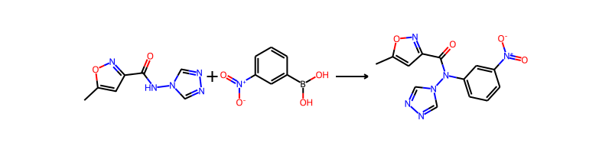

## Product 125



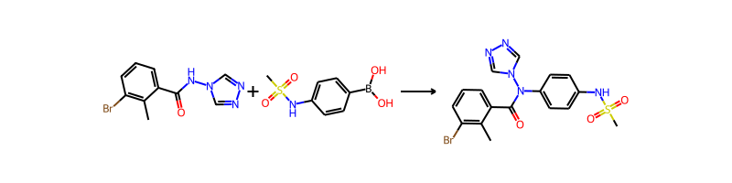

## Product 126

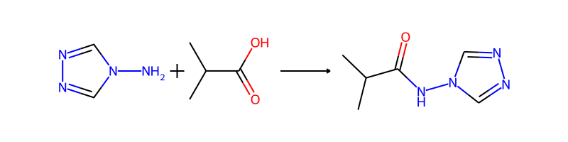

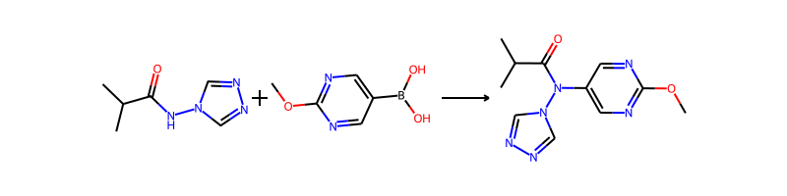

## Product 127



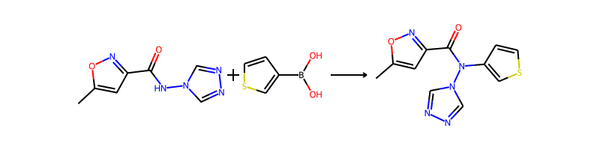

## Product 128



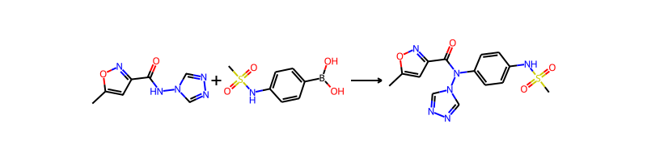

## Product 129



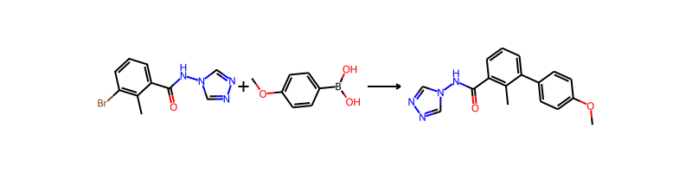

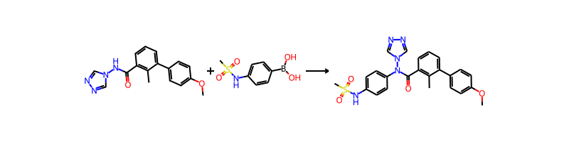

## Product 130



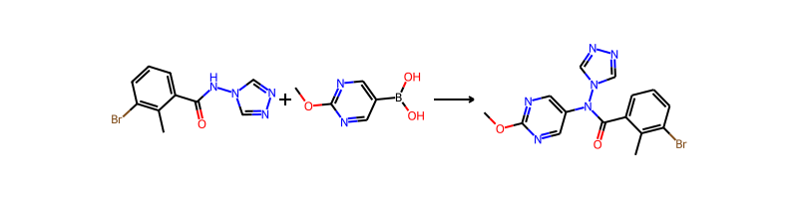

## Product 131

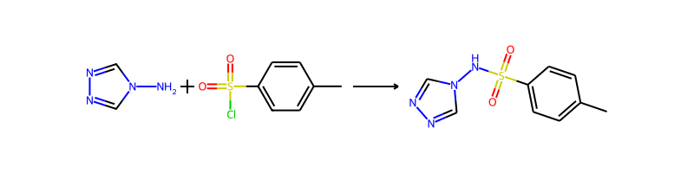

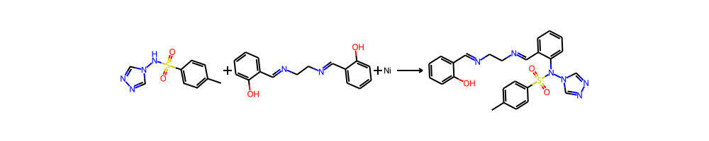

## Product 132

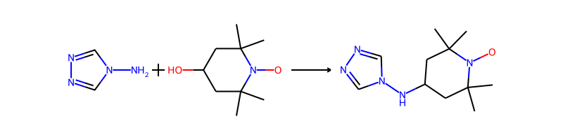

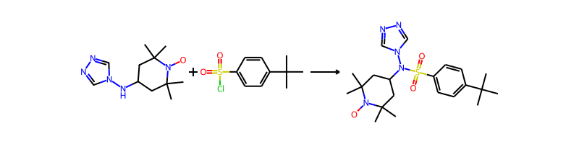

## Product 133

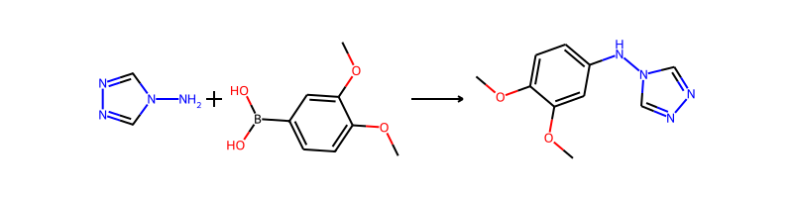

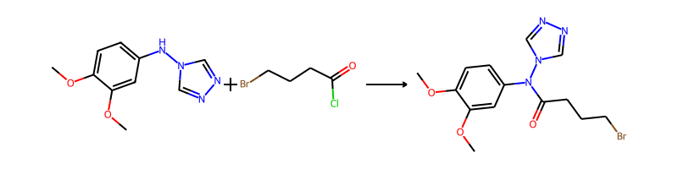

## Product 134



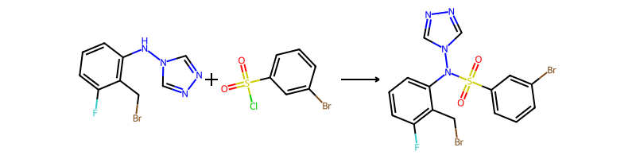

## Product 135

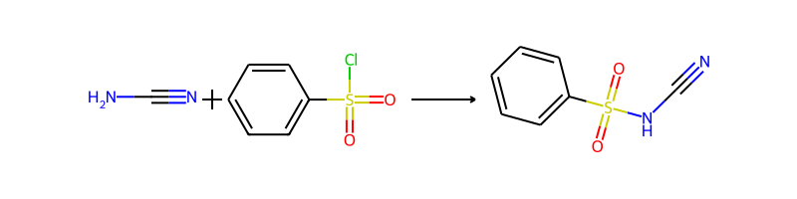

## Product 136

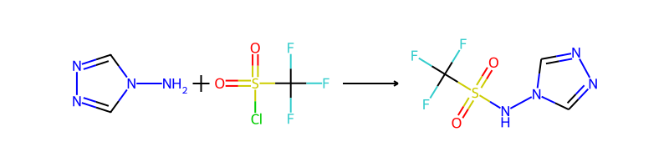

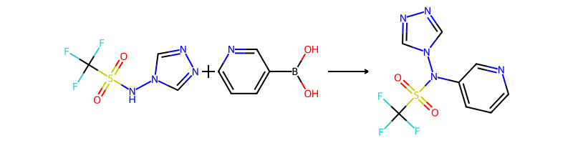

## Product 137

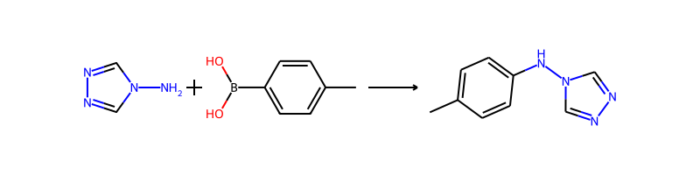

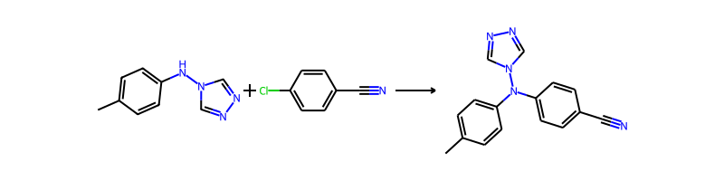

## Product 138



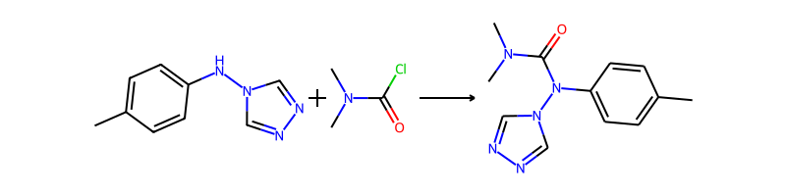

## Product 139

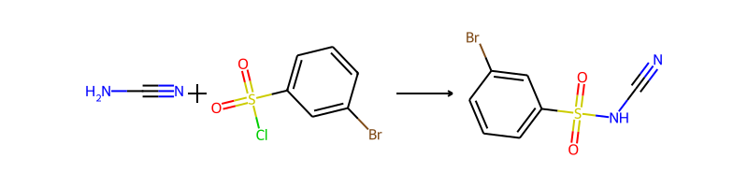

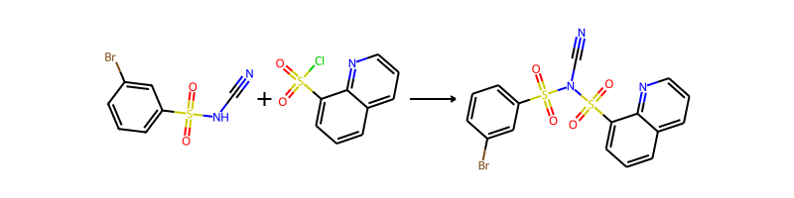

## Product 140

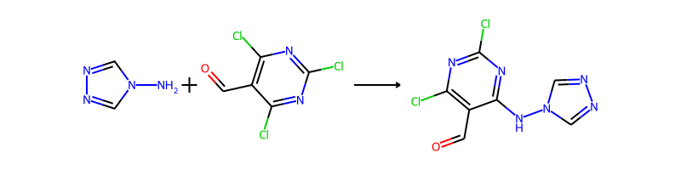

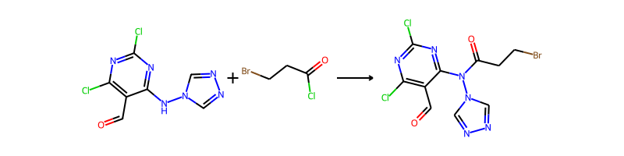

## Product 141



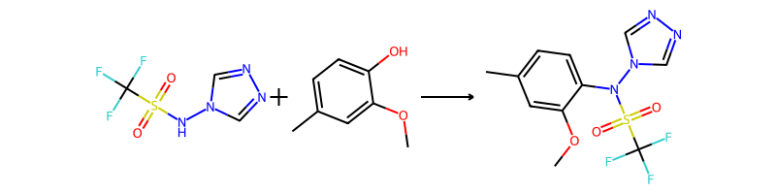

## Product 142

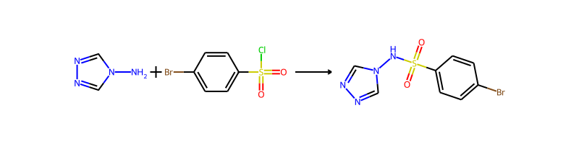

## Product 143

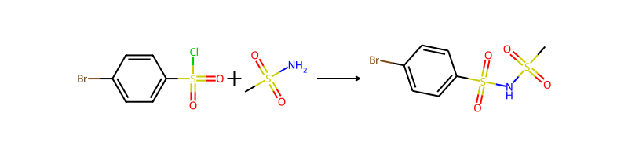

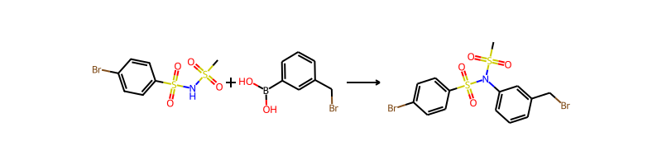

## Product 144

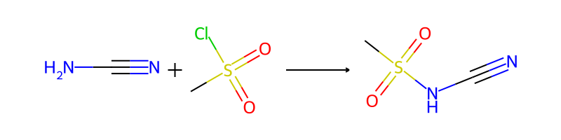

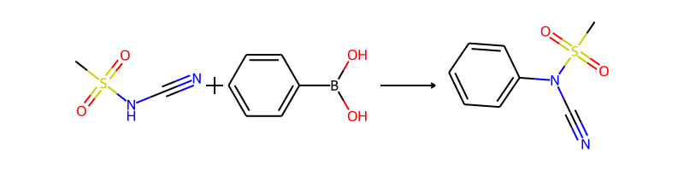

## Product 145

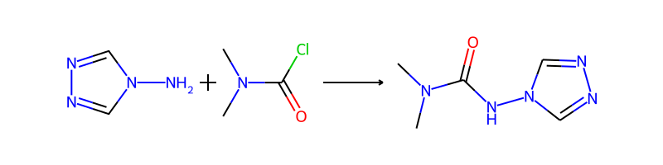

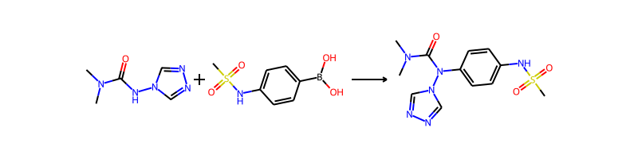

## Product 146

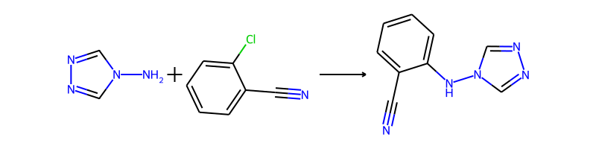

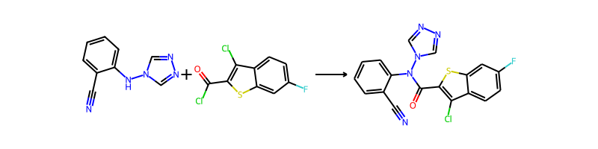

## Product 147

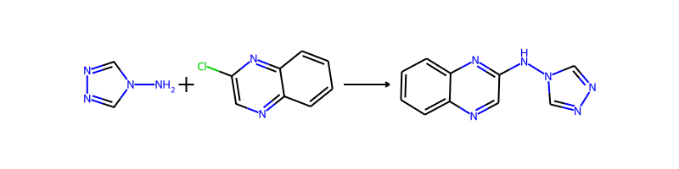

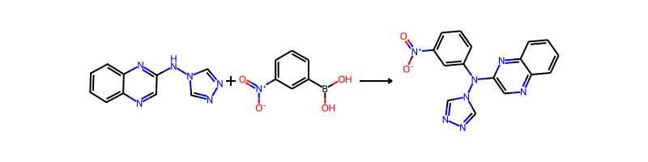

## Product 148

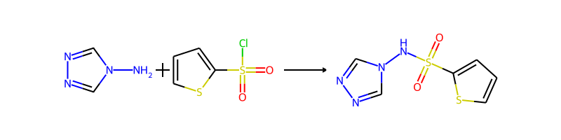

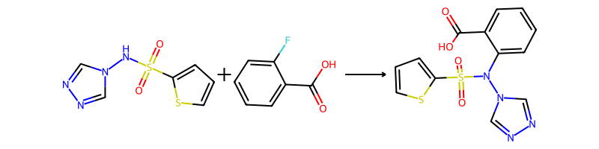

## Product 149



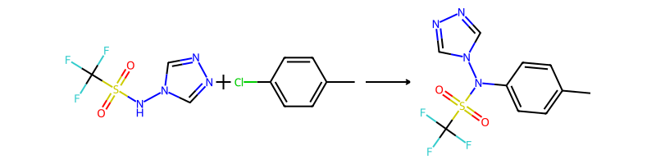

## Product 150



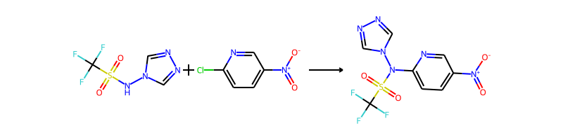

## Product 151

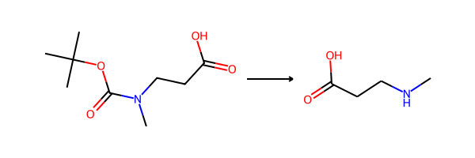

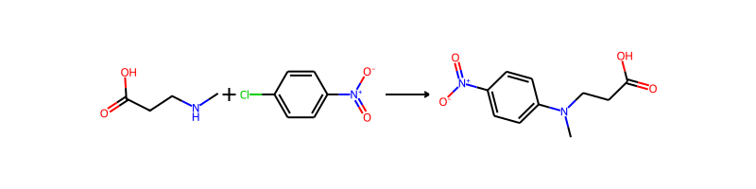

## Product 152

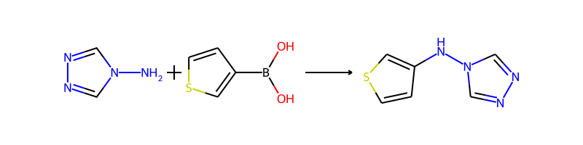

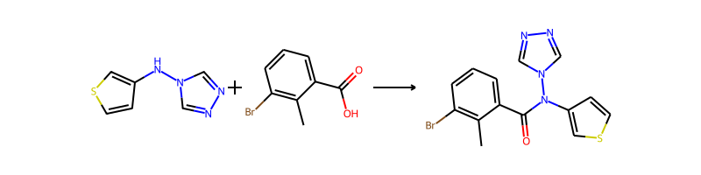

## Product 153

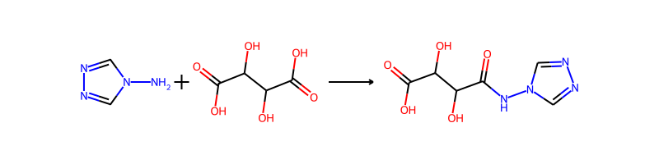

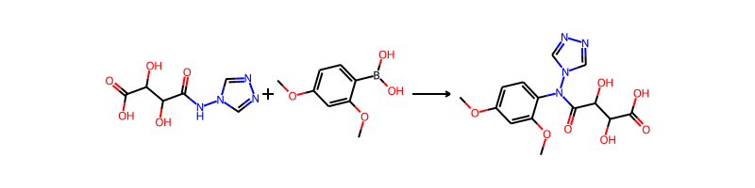

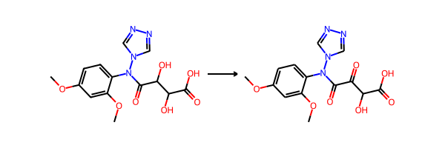

## Product 154



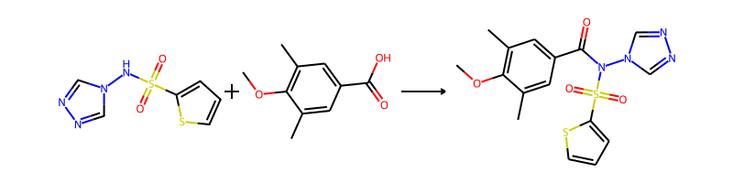

## Product 155

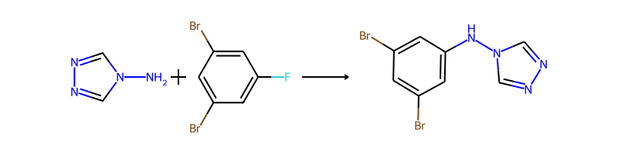

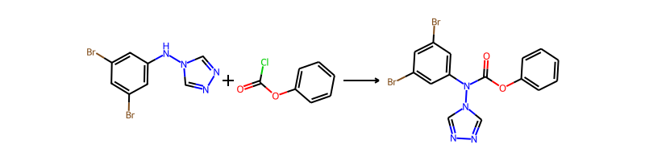

## Product 156



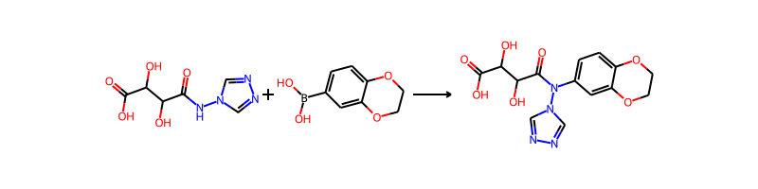

## Product 157

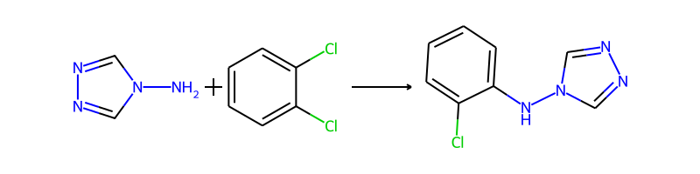

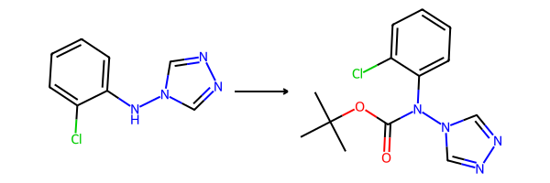

## Product 158





## Product 159



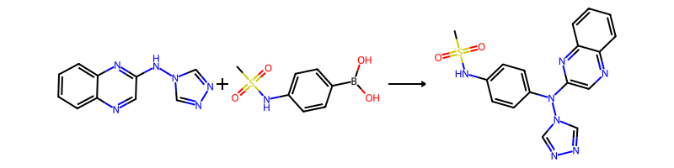

## Product 160



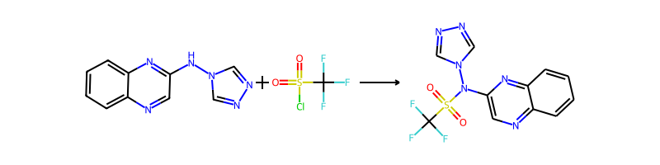

## Product 161

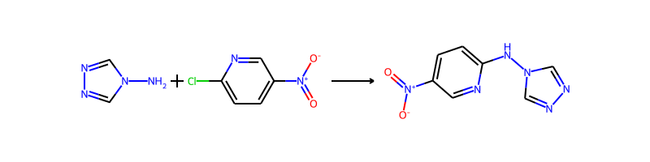

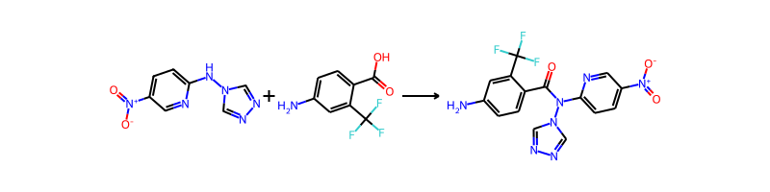

## Product 162



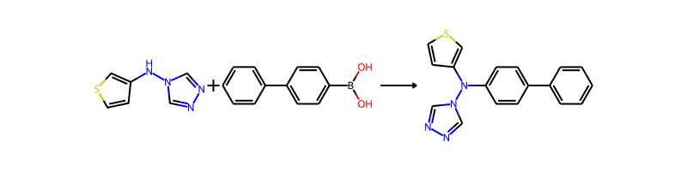

## Product 163

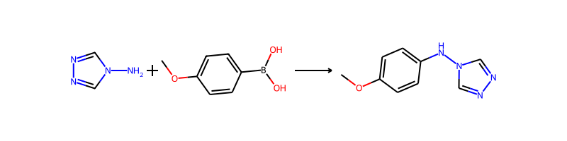

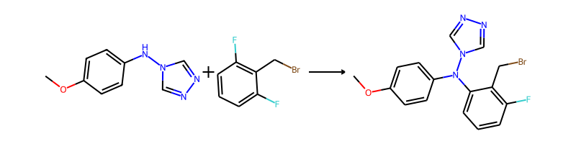

## Product 164



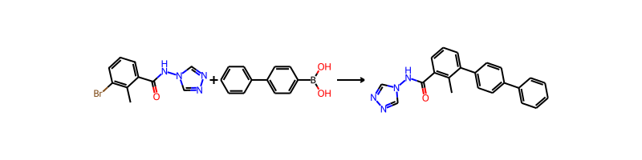

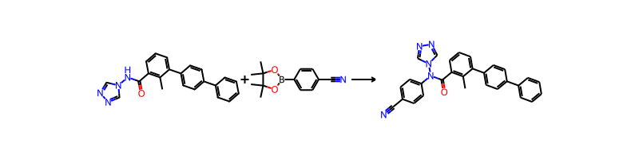

## Product 165



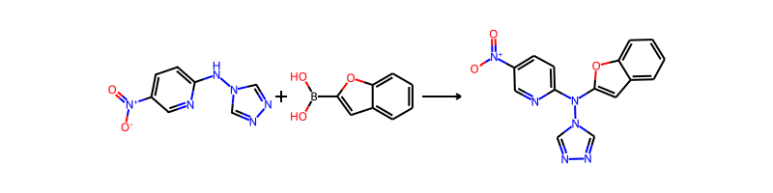

## Product 166



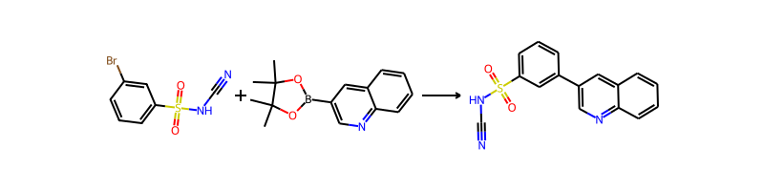

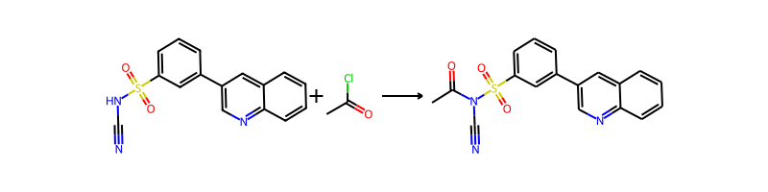

## Product 167



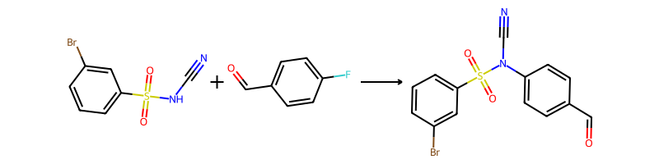

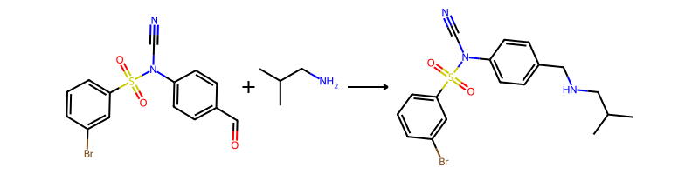

## Product 168

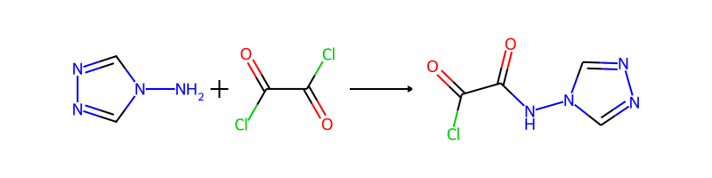

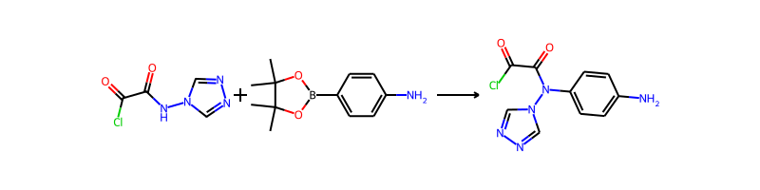

## Product 169

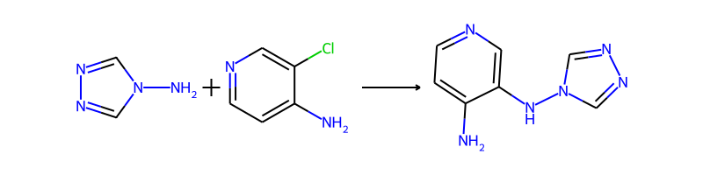

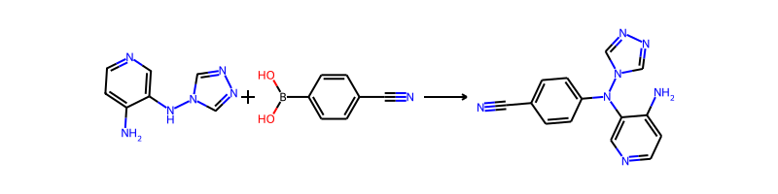

## Product 170

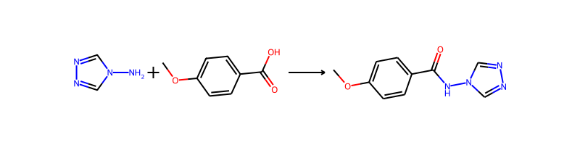

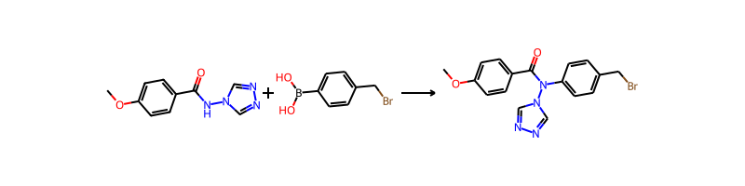

## Product 171

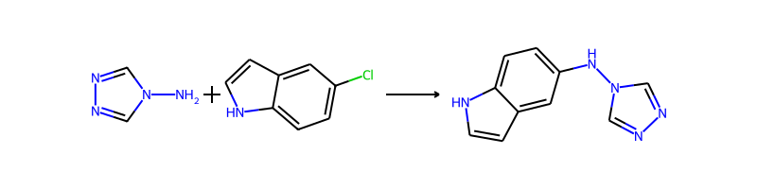

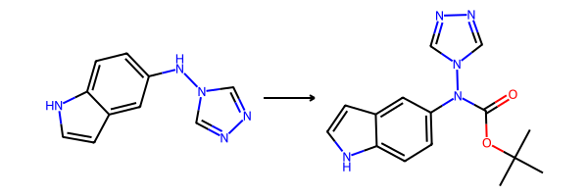

## Product 172

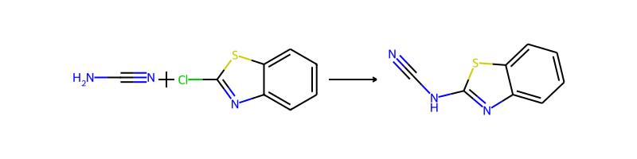

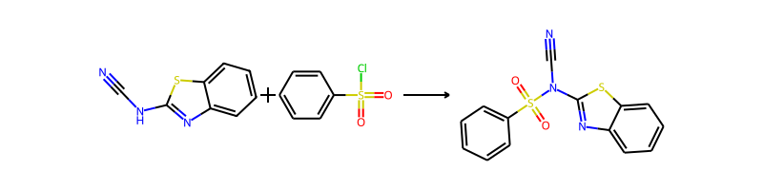

## Product 173



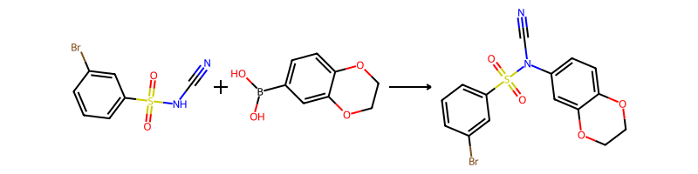

## Product 174

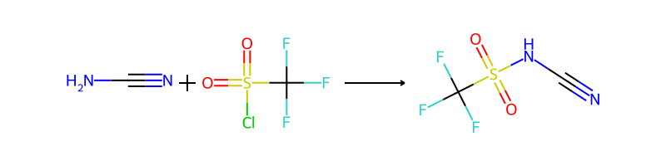

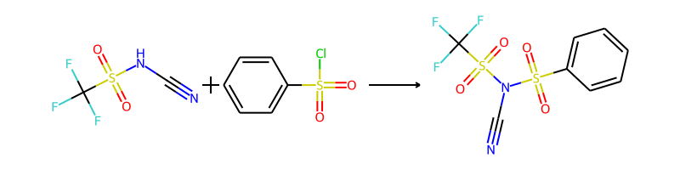

## Product 175



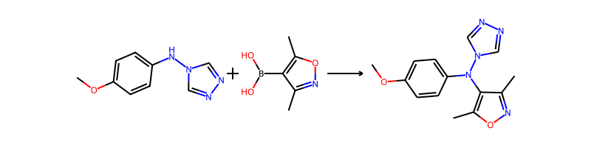

## Product 176

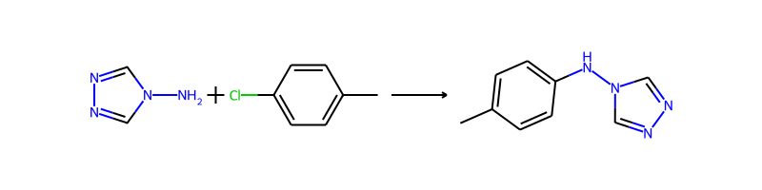

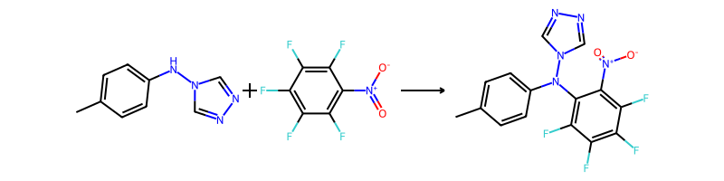

## Product 177

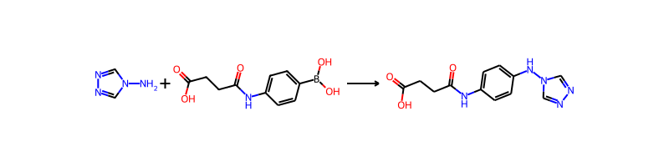

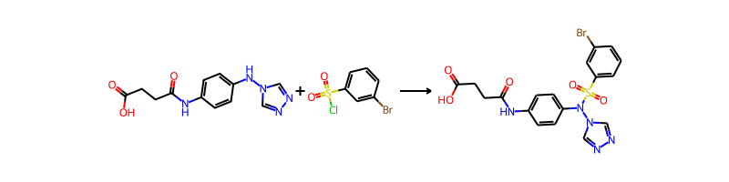

## Product 178



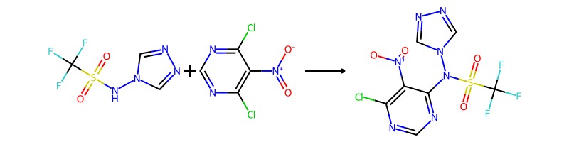

## Product 179

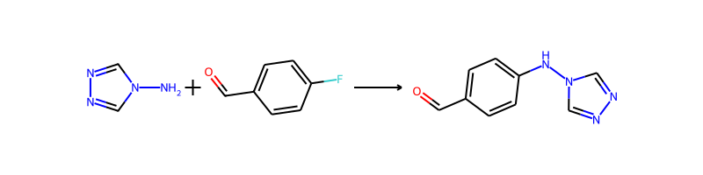

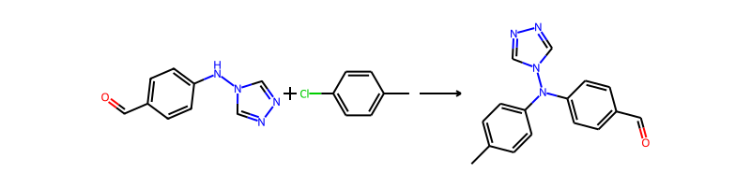

## Product 180





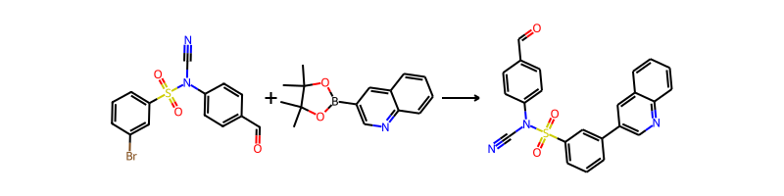

## Product 181



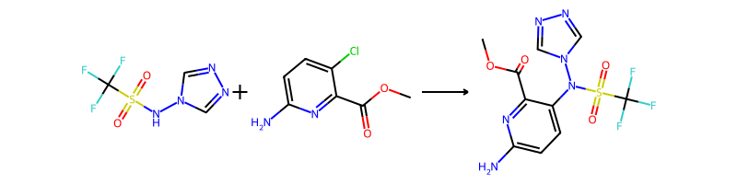

## Product 182



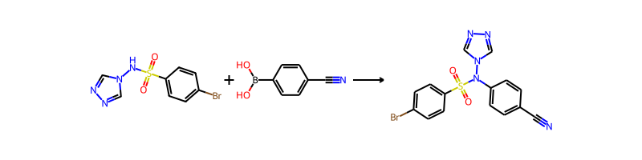

## Product 183

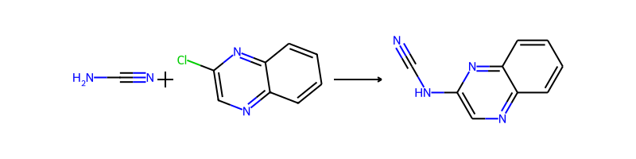

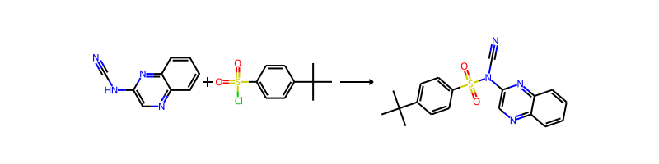

## Product 184

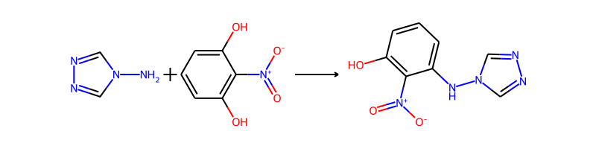

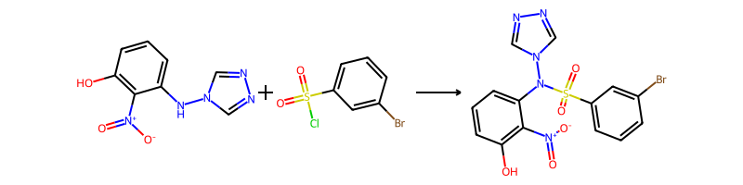

## Product 185



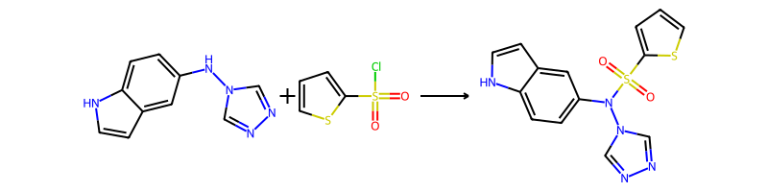

## Product 186



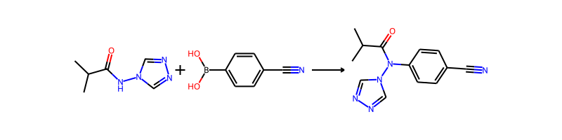

## Product 187

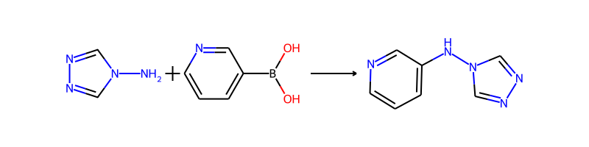

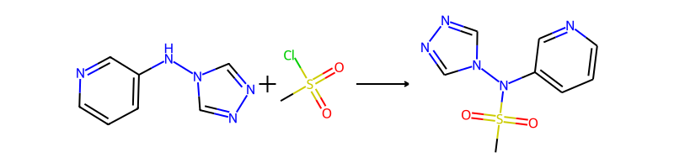

## Product 188



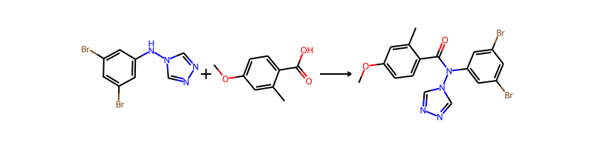

## Product 189



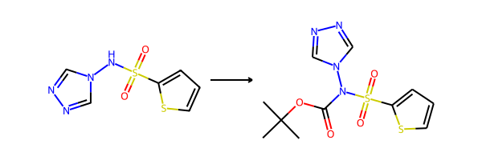

## Product 190



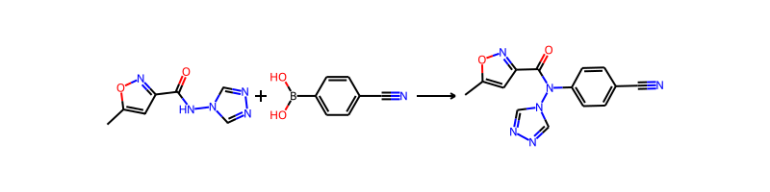

## Product 191



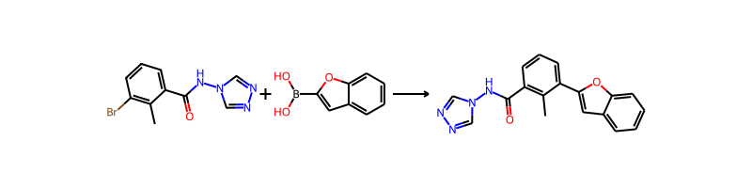

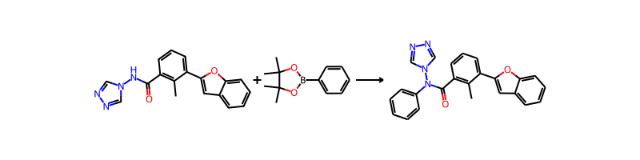

## Product 192

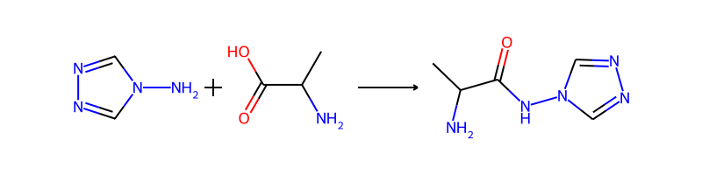

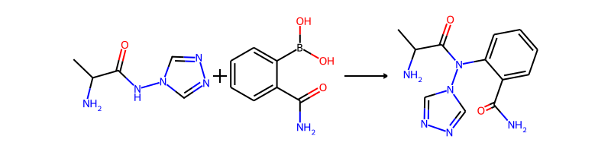

## Product 193

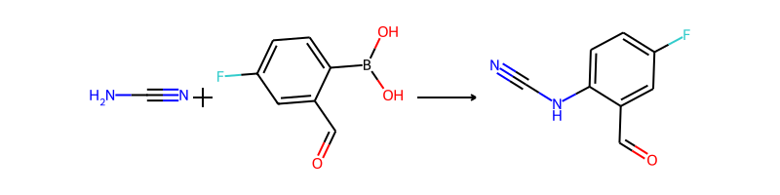

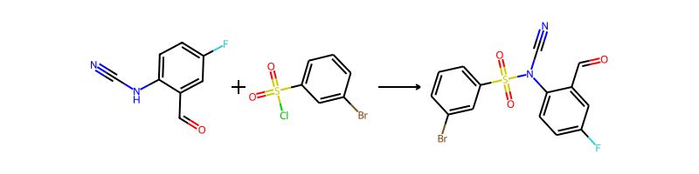

## Product 194



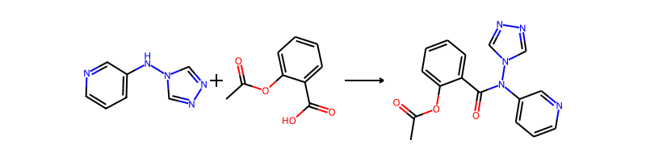

## Product 195

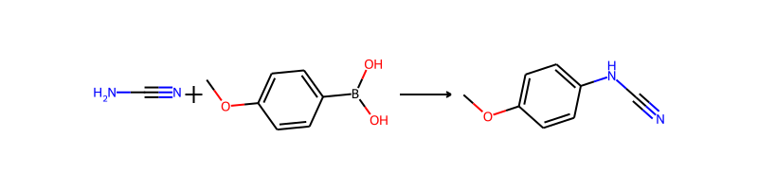

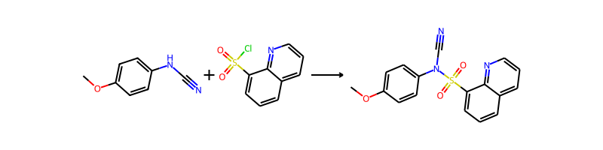

## Product 196

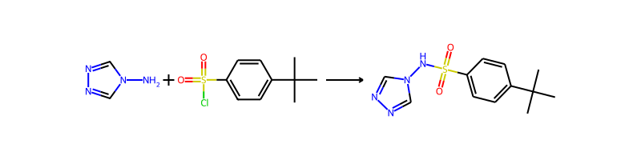

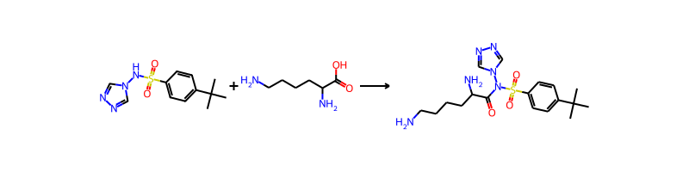

## Product 197



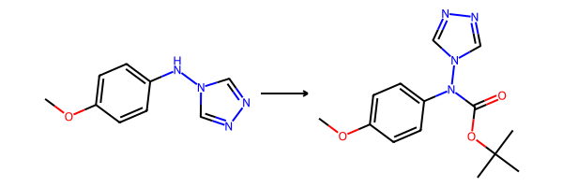

## Product 198



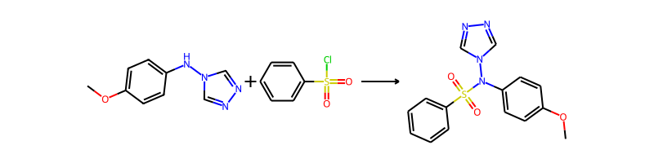

## Product 199

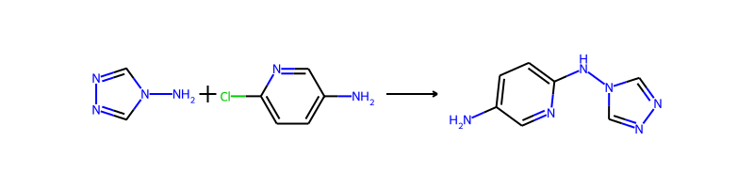

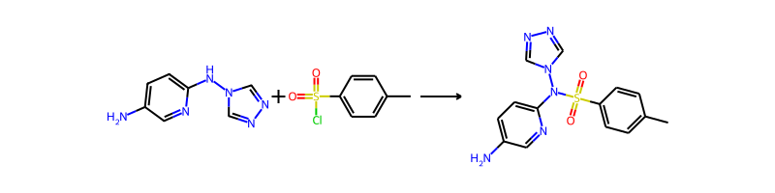

## Product 200

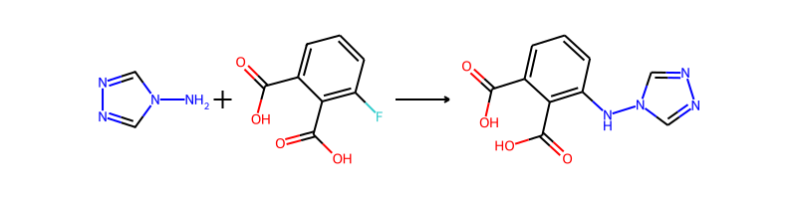

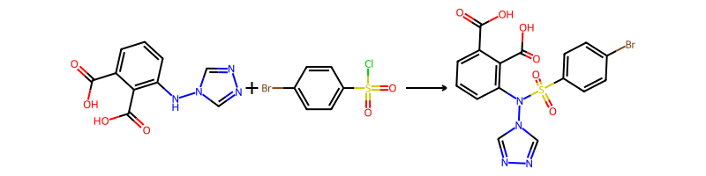

## Product 201



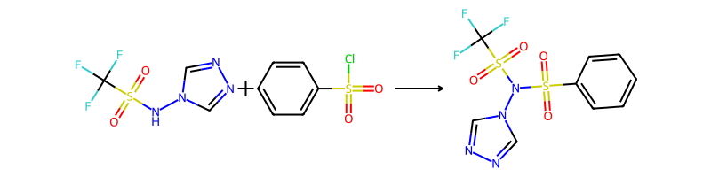

## Product 202

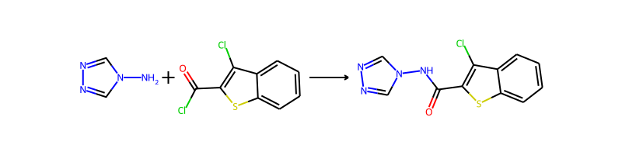

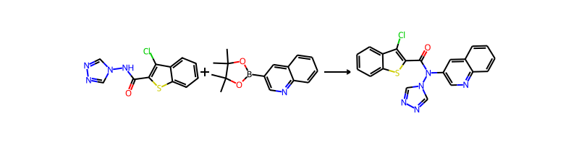

## Product 203

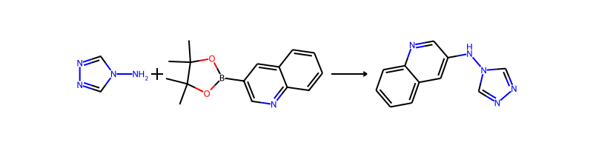

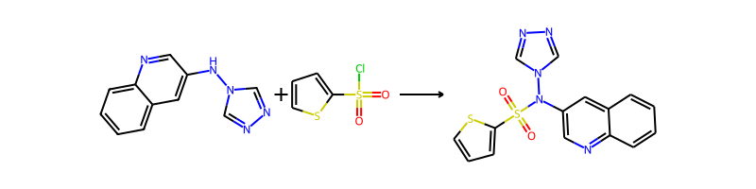

## Product 204



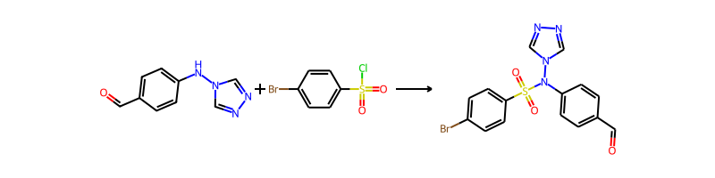

## Product 205



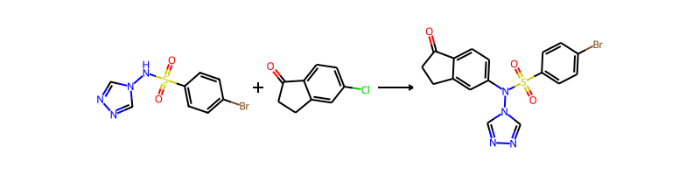

## Product 206



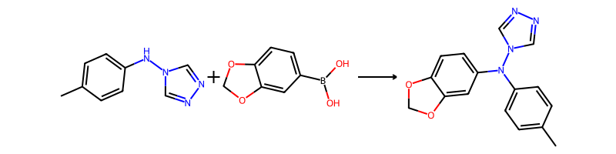

## Product 207

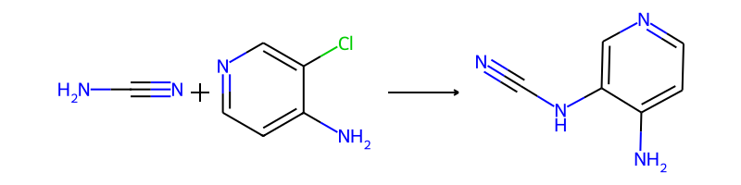

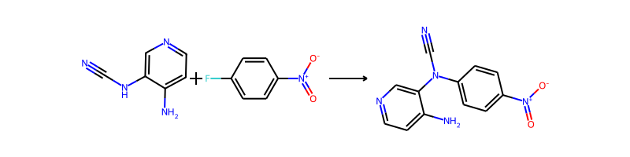

## Product 208



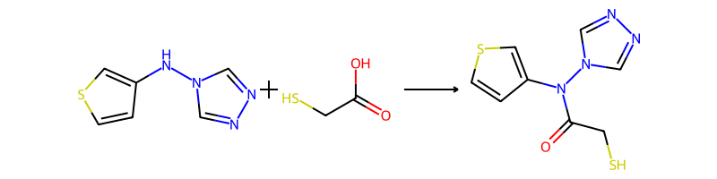

## Product 209

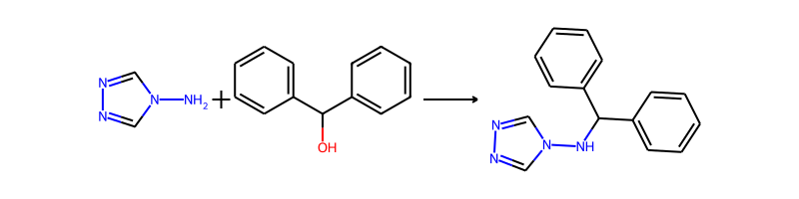

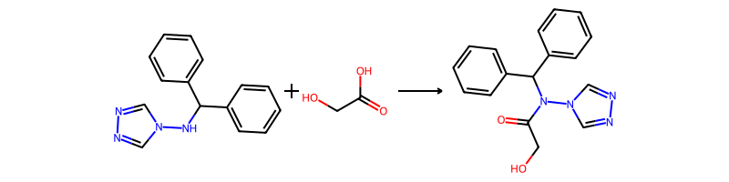

## Product 210

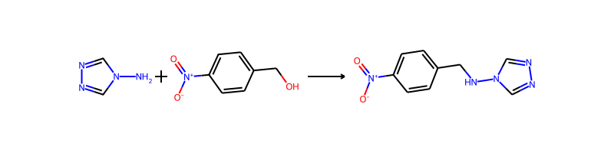

## Product 211



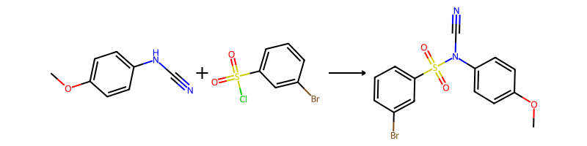

## Product 212



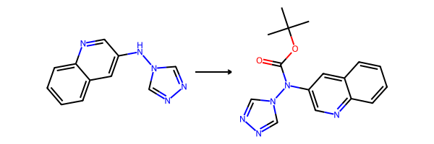

## Product 213



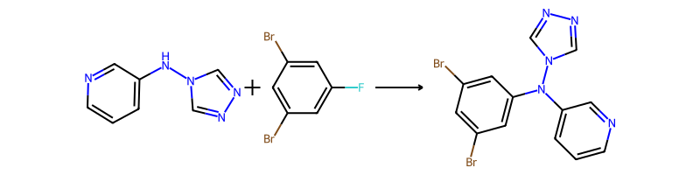

## Product 214



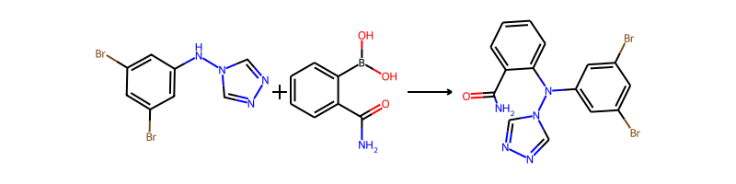

## Product 215



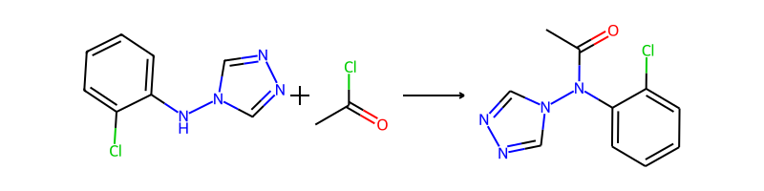

## Product 216

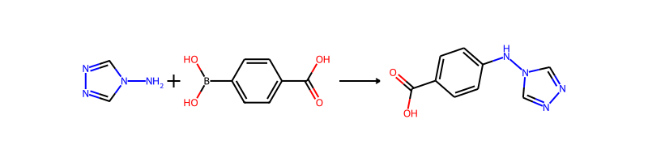

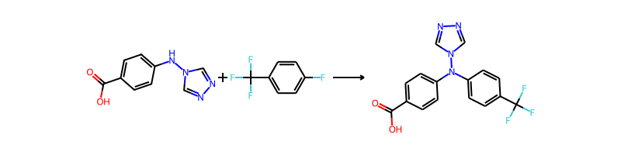

## Product 217



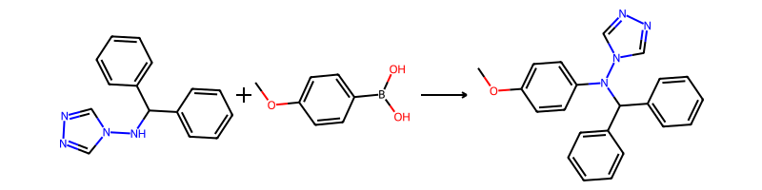

## Product 218

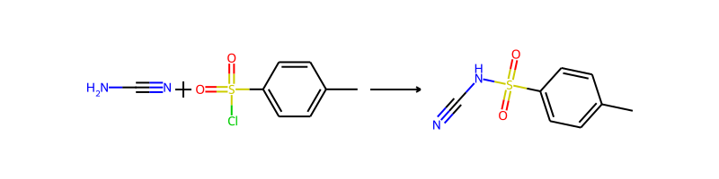

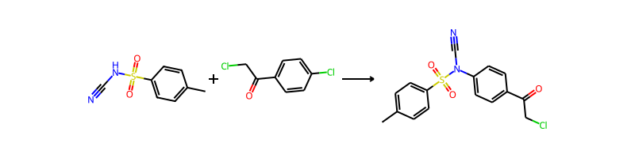

## Product 219

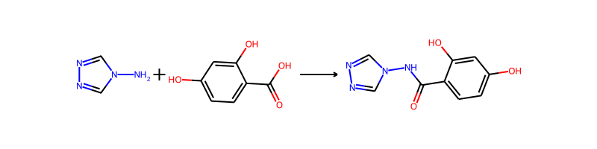

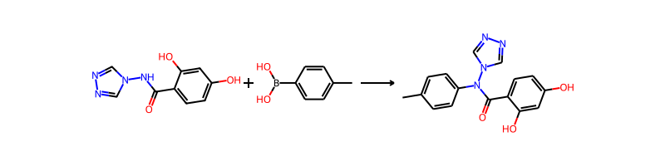

## Product 220



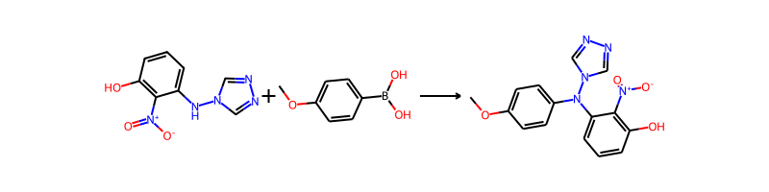

## Product 221



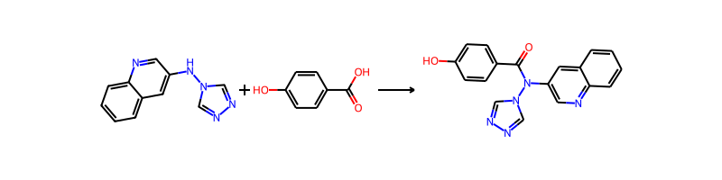

## Product 222



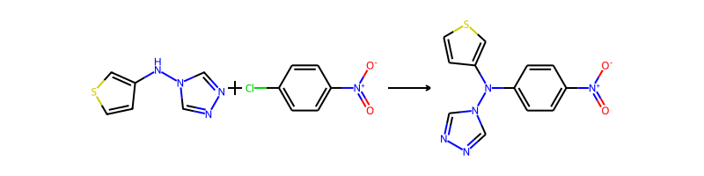

## Product 223

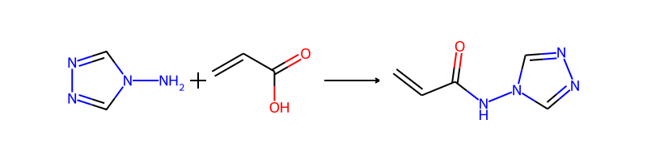

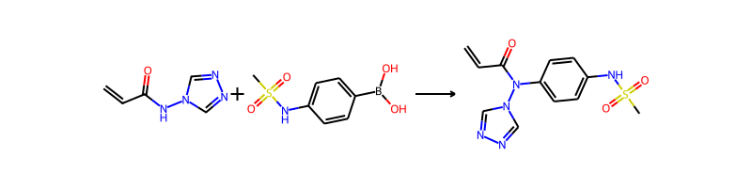

## Product 224



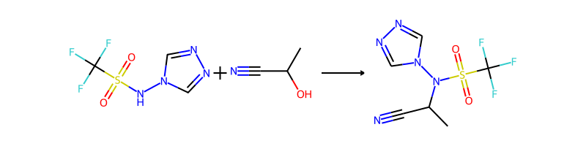

## Product 225

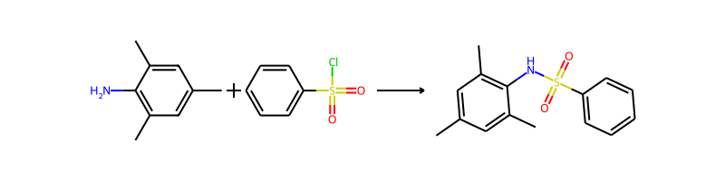

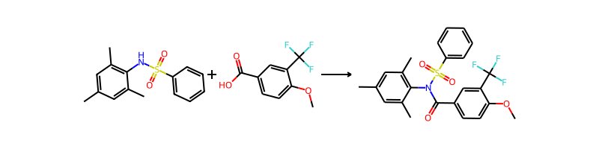

## Product 226



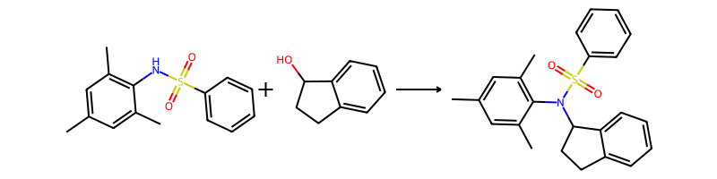

## Product 227



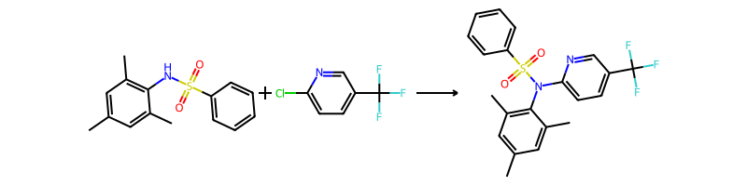

## Product 228



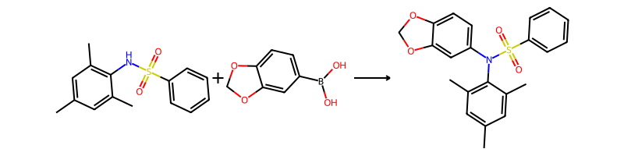

## Product 229

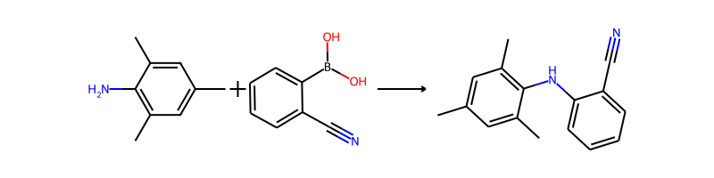

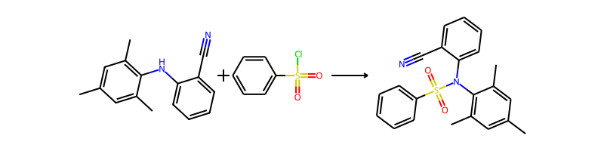

## Product 230

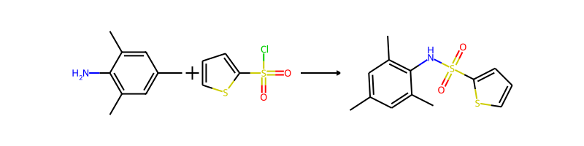

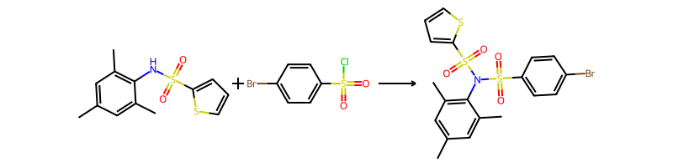

## Product 231



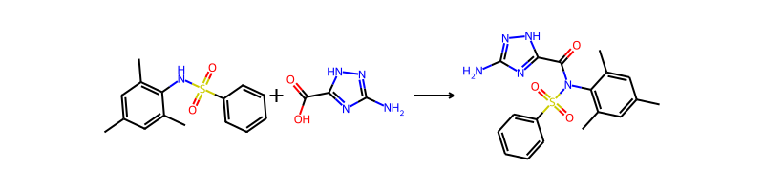

## Product 232



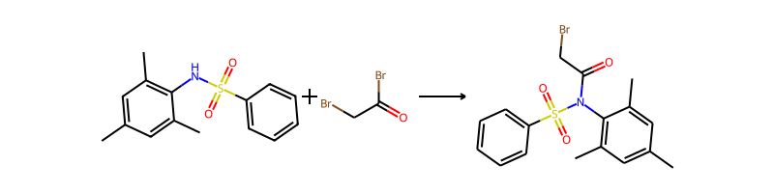

## Product 233



